
UNIT 3b

NAME: Nr. CLASS:
DATE: EVALUATION:
TEACHER: E. E.

REINFORCEMENT

Vocabulary

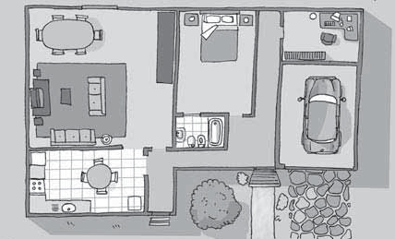1 Name the parts of the house.

4 6

1
3
5

2

1)
2)
3)
4)
5)
6)

2 Where do people do these things.

1) I make coffe in the .

2) I sleep on my .

3) I take a quick shower in my .

4) I watch TV in my .

5) I have dinner with my family in the
.
3 Write six objects you can find in a bedroom.

1) b

2) w w

3) l p

4) w e

5) d k

6) c r

The home
4 Complete the words.

1) I have got a so sys
in my bedroom.

2) Our coo is new.

3) Close the wi ! It’s really cold in here.

4) There is a lot of food in the cu .
5) I’ve got some great clothes in my

war .

6) I love the Liverpool FC pi
on my bed.

5 Complete the sentences.

mirror | carpet | shelf floor | wall | plants

1) I look in the every morning when I brush my teeth.

2) There are a lot of posters on my .

3) My favourite books are on my

4) My need water every day.

5) The cats love lying on the warm .

6) They don’t like lying on the

Grammar

Prepositions of place
1 Find the prepositions.

- ndsisoleunderalsjeiwdndxk

- betwsiwosjnexttoakawidwla

- heaobehindaksiwehwpsdnw

- bewiaosalwaxbshabovemdk

- ajsndjncdjkbetweenamdkwp

- sjfnewusinfrontofafersgdbcl

there is/there are: questions
2 Complete the questions and answers.

1) there many tourists in New
York? Yes, there are.

2) there an underground or metro system? Yes, there is.

3) Are there good museums?
Yes, there are.

4) Is there famous park?
Yes, there is. It’s called Central Park.

5) Are there mountains in the city?

No, there .

6) Are there a lot of things to see?

Yes, there .

Object pronouns
3 Circle the correct option.

1) On your next holiday, please come and visit you/me .

2) I live in a fantastic city. Tourists love it/him.

3) My neighbour is Robbie Williams. Do you know him/it?

4) He says hi to my brother and me when he sees me/us.

5) There are a lot of famous people in LA.
You see them/us on the street.

6) Tonight Christina Aguilera is giving a concert. I really like her/him.
have got
4 True or false? Correct the false sentences.

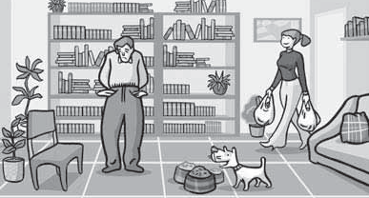

1) He’s got a lot of money.

2) They’ve got a lot of plants.

3) They haven’t got a lot of books.

4) They haven’t got a TV.

5) She’s got a lot of bags.

6) They’ve got a lot of chairs.

7) The dog’s got a lot of food.

have got: questions
5 Complete the questions.

what | has | have has | have | got

1) you got a lot of friends?
Yes, at school and on my street.

2) Have all your friends a mobile?
Yes, they have.

3) have you got on your bedroom wall?
I’ve got posters and a calendar.

4) your flat got a garden?
No, it hasn’t.

5) your dad got a car?
Yes, he has. But he prefers his bike.

6) you got a favourite website?
Yes, I have. It’s YouTube.

5

