
UNIT 6a

NAME: Nr. CLASS:
DATE: EVALUATION:
TEACHER: E. E.

REINFORCEMENT

Vocabulary

Healthy habits
1 Circle the correct option.

1) It’s good for you to eat a balanced diet/
eat junk food.

2) It’s good for you to drink plenty of water/
drink a lot of caffeine.

3) When you’re studying it’s good for you to
take regular breaks/stay up late.

4) It isn’t good for you to spend a lot of time
watching TV/doing regular exercise.

5) It isn’t good for you to take time to relax/
get stressed.

6) It isn’t good for you to stay inside all the time/
do regular exercise.

2 Complete the sentences.
Body words
3 Complete the words.

1) When I do tai chi, I st up.

2) I hold my ar out and imagine I’m holding a tree.

3) I in and feel the air going into my body.

4) I ex and feel the tension go out of my body.

5) My ba is straight.

6) At the end I fe very relaxed.

4 Complete the sentences.

sit | feel | lie down stand up | eyes | breathe

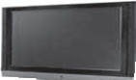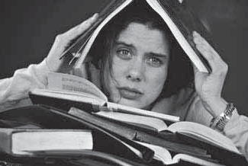1 2 3

4 5 6

Say no to school stress!

1) You’re very tired and you want to

1) I like to eat a b d .

2) Of course I d p of water.

3) I don’t spend a lot of t

w TV.

4) It’s not a good idea to s

i all the time.

5) My doctor says I shouldn’t eat j

f .
6) And the most important thing is: I never g s .

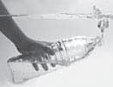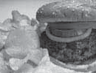 and sleep.

2) But you’re at school! And you
very stressed.

3) The first thing you should do is

. This helps you to relax.

4) Close your for one minute.
Count to ten.

5) , go outside and maybe go for a walk.

6) When you are tired, down and forget about your problems.

Grammar

should
1 Circle the correct option.

THE TEACHER’S TIPS

1) You should/shouldn’t only speak English in class. It’s easier than you think!

2) You should/shouldn’t write down 5-8 new words in every class.

3) You should/shouldn’t do English homework.
Class work isn’t enough.

4) You should/shouldn’t read song lyrics in
English. They’re normally on the Internet.

5) You should/shouldn’t think it’s impossible.
It’s possible when you think positively.

6) You should/shouldn’t be horrible to your teacher. The teacher’s here to help you.

should: questions
2 Order the questions.

1) what / I / do / in / should / the summer ?

You should read a book in English.

2) I / watch / films / should / in English ?

Yes, especially when they have subtitles.

3) should / I look / at / which / Internet sites ?

youtube.com have a lot of videos in English.

4) use / the BBC website / should / I ?

Yes, you should. It’s a very good website.

5) where / I / should / go / to learn quickly ?

You could go to the UK, Ireland or another
English speaking country.

6) should / pay attention / lyrics / in / songs / English / to / the ?

must
3 Write sentences with must and mustn’t.

SCHOOL LIBRARY RULES

1) write on the books X

2) speak on the phone X

3) bring back the books after two weeks .I

4) eat or drink in the library X

5) run in the library X

6) have a library card to use the library .I

must vs. should
4 Complete the sentences.

must | should | should shouldn’t | mustn’t | must

1) You go to school until you are eighteen. It’s the law.

2) You smoke in the school, or outside the school. It’s prohibited!

3) You respect the other students and the teachers. We think it’s a good idea.

4) The teachers and students leave the school before 6 p.m., when the school closes.

5) You try to study a little more. The exams are in two months.

6) You get stressed about the exams. Take regular breaks and try to relax.

Yes, you should it´s a good idea.

IN

