
UNIT 6b

NAME: Nr. CLASS:
DATE: EVALUATION:
TEACHER: E. E.

REINFORCEMENT

Vocabulary

Measurements
1 Complete the words.

I love Sports Day at school.



1) We train for a long t during the year: every day for two hours.

2) There’s a youth marathon. We run

a dis of six miles.

3) The bicycle race is really fast.

The sp is incredible.

4) The tem in summer’s about 22 ºC, so we drink a lot of water.

5) The typical we of a student wrestler is 50 kilos.

6) You can be any he to do sport.

2 Order the letters.

1) What was the yesterday?
It was about 20 ºC. (peratemture)

2) What did you jump? I don’t know, but I won! (eighth)

3) Do you know the of this race? Yes, it’s 100 metres. (englth)

4) Are you going to study now? No, I need to spend some relaxing. (emit)
5) What’s the between your
house and your school? One mile. (isdancet)

6) Do you know your ? No, but after Sports Day it’s a few kilos less. (ghtwei)
Life plans
3 Circle the correct option.

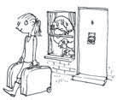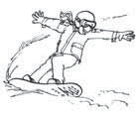1 4

2 5

3 6

1) I want to be rich/have children.

2) When I’m twenty, I’m going to do
voluntary work/leave home.

3) It’s important to get a job/get married.

4) I hope I get a flat/have good friends.

5) I wouldn’t like to go to university/be famous.
It’s probably very annoying.

6) My mother always says I should
have a good time/get a flat.

4 Complete the dialogue.

voluntary | world | successful university | live | job

Lee After school I’m going to (1) .
I want to study IT and languages.

Tamsin I’d like to do (2) work first.

And travel around the (3) .
Lee You’ll need money. You’ll need to get a (4) . I’m going to
(5) abroad. Maybe in Japan.
Lee I’m not sure about the job I want. But I want

to be (6) .

Grammar

will : facts
1 Circle the correct option.

1) The 2012 Olympic Games will/won’t be in London.

2) Sophie’s twelve years old. In five years she
will/won’t be twenty.

3) Next July will/won’t have 31 days.

4) One day our sun will/won’t die.

5) We will/won’t live on the Moon next year.

6) Next year my grandmother will/won’t be fifteen years old.

going to
4 Write the plans for the weekend.

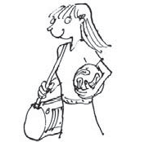1 4

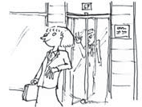2 5

will : questions
2 Complete the words in the questions.

1) W w you be in 2015?
I think I’ll be in London.

2) W w you do?
I’ll study to be an actor at Drama School.

3) Will you l with family or friends?
I have a cousin in London. I’ll live with her.

4) H long w you live in London?
For four years, maybe longer.

5) W w you do after Drama School?
I’ll work in the theatre.

6) W you b successful?
Yes, I think so. I’ll work very hard.

will : predictions
3 Complete the sentences with will/won’t
and probably.

My best friends are Robin, Darragh and Joe.

1) I live in a big city because our town is small and boring.

2) Robin live in a city.
She doesn’t like busy streets and noise.

3) She study medicine because she wants to be a doctor.

4) Darragh go to Rome because he loves Italian culture.

5) Joe stay here because he wants to travel.

6) Our lives be very different.

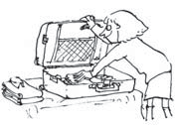3 6

1) play football

2) make lunch for his friends

3) study all weekend

4) have a good time this weekend

5) work extra hours

6) visit her friends in Mexico

