
UNIT 7

NAME: Nr. CLASS:
DATE: EVALUATION:
TEACHER: E. E.

REINFORCEMENT

Vocabulary

Superstitions
1 Order the letters.

1) There’s a . Let’s throw some coins in it. (tainnouf )

2) On New Year’s Eve don’t forget to wear your yellow . (earunderw)
3) In China people give children money in

a red . (veloenpe)

4) Where’s my ? All my money is in it. (urspe)

5) I’m going to cry. Have you got
a ? (kerchiefdanh)

6) I’m going to keep this for good luck. (shhorseoe)

2 Complete the words.
I had a very lucky morning. I found a white (1) sn under my bed. It was a toy! I ate (2) le because it’s 1st January, and I’m Italian. We also hung a (3) hor
with the two ends pointing up.
The afternoon wasn’t so lucky. I walked under a
(4) la on the street. Then I went to the bathroom and I looked in a broken (5) mi .
Later I needed money for a coffee, so I took (6)

co from a fountain. So will I have good or bad luck now?
Causes
3 Complete the sentences.

support | promotes | donates remember | take | do

1) Everybody should things to help the environment.

2) If we don’t action, the situation will get worse.

3) My friends and I charities like Greenpeace.

4) I haven’t got any money, but my mum

money to Greenpeace.

5) My school also recycling.
We collect bottles and paper to recycle.

6) We should that this is a global problem. We need a global solution.

4 Underline the words.

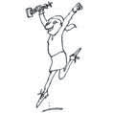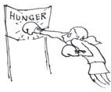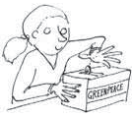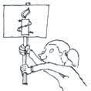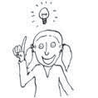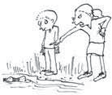1 4

2 5

3 6

1) b s t e u w c e l e b r a t e t h a i e w h s n

2) h d s t e f i g h t a g a i n s t d h e t g a l d r

3) d g e t a s g d o n a t e r s h w t s j s d n k

4) t e g s u p p o r t p h a t w f e g d b x j s i t

5) r e f d g h a l o p r e m e m b e r h a d t e

6) j e h f t a k e a c t i o n s h e t a d k e i d l s

Grammar

First conditional
1 Complete the dialogue.

some/any/no + body/thing/
where
3 Write some, any or no in the sentences.

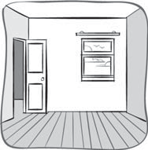study | hear | won’t | ’ll do | tells | ’ll stay 1 4

Mum If you study hard, (1) you well in the exam.

Dennis But if Dad (2) me to tidy, I’ll have to do that.

Mum Dad won’t ask you to tidy, if you (3) .

Dennis If Jenny listens to loud music, it (4)
be possible to study.

Mum Jenny! If I (5) that music again, I
won’t give you any pocket money.

Jenny But Mum, if I have no money, (6) I in my room and play music.

First conditional: questions
2 Circle the correct option in the questions.

1) What will you do if you don’t/won’t
understand the homework? I’ll ask my brother for help.

2) What will you do if he doesn’t/will help you?
I’ll tell my dad.

3) Will you don’t come/come to my house if you finish earlier?
OK, if I have time.

4) Will Mark and Jessi be there if I will go/go?
Yes, they’ll be here.

5) Will Mark’s mum take me home if my dad
can/can’t collect me? Yes, I’m sure she will.

6) Will you order pizza if we’re/we’ll be hungry.
No, but we can make pizza in my kitchen.

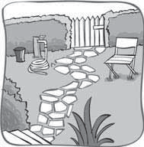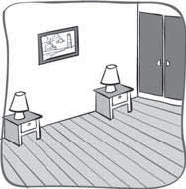2 5

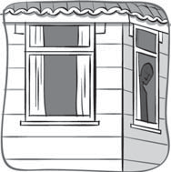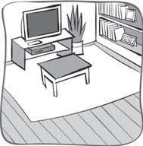3 6

1) Is there body in the house?

2) There’s body in the garden.

3) But there’s body in the living room.

4) There’s thing in this room.

5) You need thing to sleep on in a bedroom.

6) Is there where to sit in this room?

every + body/thing/where
4 Complete the sentences.

1) My brother thinks he knows .

2) I know does voluntary work.

3) I take my MP3 player I go.

4) There was a robbery. The police want to speak to .
5) Tea’s ready. I cooked earlier.

6) The paparazzi follow me .

