
UNIT 8

NAME: Nr. CLASS:
DATE: EVALUATION:
TEACHER: E. E.

REINFORCEMENT

Vocabulary

More jobs
1 Find the jobs.

1) h w t a d e f g r e n g i n e e r h d s a t e w

2) a s w t e r d a r c h i t e c t a h s i o e p m a

3) l a b s t e r w l a w y e r g s b a h c u i e o

4) a w q s a d y j o u r n a l i s t l i o u r j e l t

5) k j i c o m p u t e r p r o g r a m m e r m o

6) i u w r a d s c h s g e r w w a i t e r o g a r

2 Complete the jobs.
Life experiences
3 Circle the correct option.

1) Edie’s eaten snails/a poem.

2) She’s spoken to a Valentine’s card/
famous person. It was Venus Williams!

3) She’s also written a prize/a poem. It was called ‘Teenage Love’.

4) Edie’s got a pop group. They sang
a song in public/home after midnight.

5) It was a song contest. They were first, so she’s won a prize/a poem.

6) But there are some things she hasn’t done.
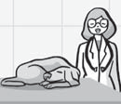She hasn’t been on a roller coaster/to a famous person.

1 2 3
4 Complete the sentences.

4 5 6

1) Debra wants to be a v .

2) At the weekend Paul works as

a hai .

3) Mark’s going to be a soc

wor .

4) Celia’s learning to be

a me because she loves cars.

5) If you want to be a sh

as , you should be friendly.

6) Clare works as a ch at the weekend.
roller coaster | poem | Valentine’s snails | midnight | person

1) Nick hasn’t eaten .

2) He hasn’t got home after .

3) He hasn’t sent anyone a card.

4) He’s seen famous footballers but he hasn’t spoken to a famous .
5) He’s written a story but he hasn’t written a .
6) But he has done one thing. He’s been on a .

Grammar

Present perfect
1 Complete the sentences.

haven’t | has | seen | have | read | made

3) How many concerts I’ve been to three concerts this year.

4) How much homework I’ve done a lot of homework.

5) Has your teacher

1) Angelina and Brad sold one of their mansions.

2) Kate Winslet’s another film with
Leonardo di Caprio.

3) A lot of people have the latest
Harry Potter book.

4) Jessica Alba had a baby.

5) I seen The Dark Knight. I’m going to watch it tomorrow.

6) We haven’t the other Batman films.
Yes, my teacher’s been happy with my work.

6) Has your mum No, my mum hasn’t been happy with my work!

just

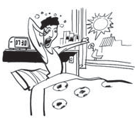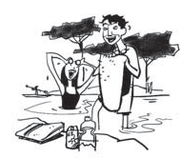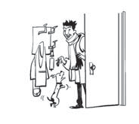1 4

been vs. gone
2 Complete the sentences.

1) Hi! magazine can’t interview Penelope Cruz because she’s to Hollywood.
2) They’ll interview Javier Bardem. Javier’s

to Hollywood, but he’s back to the UK now.

3) I’ve to the US twice. I was there in 2002 and 2007.

4) I’ve never to Mexico. I’d like to go there next year.

5) My friends have to Mexico on holiday. They’re coming back next week.

6) My parents have out, so I’m at home alone.

Present perfect: questions
3 Complete the questions.

How active are you?

1) Have you Yes, I’ve played football three times.

2) How many cities

I’ve visited two cities this year, Paris and
London.
2 5

3 6

4 Write the sentences. Use the Present perfect and just.

1) woken up

2) made a cake

3) swum in the lake

4) eaten dinner

5) arrived

6) his football team won

