
UNIT 9

NAME: Nr. CLASS:
DATE: EVALUATION:
TEACHER: E. E.

REINFORCEMENT

Vocabulary

Holidays
1 Write the words.

1) rustoothbh

2) gbooduike

3) nsu camre

4) breumlla

5) lotew

6) kninepef

7) spascom

2 Complete the words.

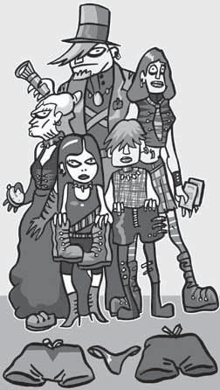

1) Mum always has the

pass with her.

2) Gran always takes a com .

3) Dad takes the to .

4) My sister takes a lot of bo .

5) I take my favourite sh .

6) We never forget our swims .
3 Complete the sentences.

guidebook | penknife | towel sun cream | passport | umbrellas

1) After swimming, dry your hair with a .
2) If it rains, we can use the .

3) We can cut things with a .

4) A has got a lot of great information for tourists.

5) When you go to another country, you need your .
6) When it’s sunny, I put on .

Rules
4 Circle the correct option.

Granny’s rules for the family:

1) Knock/Disturb before you come into my room.

2) Don’t try on/Don’t look on my clothes.

3) Don’t put/Don’t take my things. They’re not yours!

4) Don’t take me/Don’t disturb me when
I’m sleeping.

5) When you take things, put things back/
try things back.

6) Don’t touch/Don’t try on my cat.

Imperative
5 Complete the sentences.

1) Don’t l at my diary. If you have a question, ask me.

2) Don’t u my mobile phone!

3) Don’t l in my bag.

4) Please don’t d my dog when he’s asleep.

5) Don’t t my letters.

3) not break / anything

They’re private.

6) Don’t t on my boots. They’re very expensive — and they’re mine!

4) not eat / too many sweets

Grammar

Reported speech
5) not run / around the house

6) clean up / after the party

I’m really happy!
I passed my exam. My dad’s going to buy me a dog. My mum is going to be pleased about the exam. She isn’t going to be pleased about the dog. I’m sure that in
time she is going to love it.

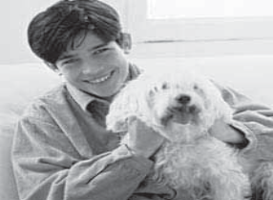1 Complete the sentences.

1) John said .

2) He said .

3) Then he said

.

4) He revealed

.

5) Finally he said

.

4

1) Don’t l at my diary. If you have a question, ask me.

2) Don’t u my mobile phone!

3) Don’t l in my bag.

4) Please don’t d my dog when he’s asleep.

5) Don’t t my letters. They’re private.

6) Don’t t on my boots. They’re very expensive — and they’re mine!

2 Circle the correct option.

1) Dad asked where/why I wanted a dog.

2) Mother asked if/when it was my responsibility.

3) His sister asked how much/when it was arriving.

4) John asked if/where the dog was allowed in the house.

5) John asked where/if it was going to sleep.

Imperative
3 Write the rules. Use the imperative.

Tom’s mother’s rules for the party.

1) not play/ music / too loud

2) finish / the party / at 12 o’clock

