School objects

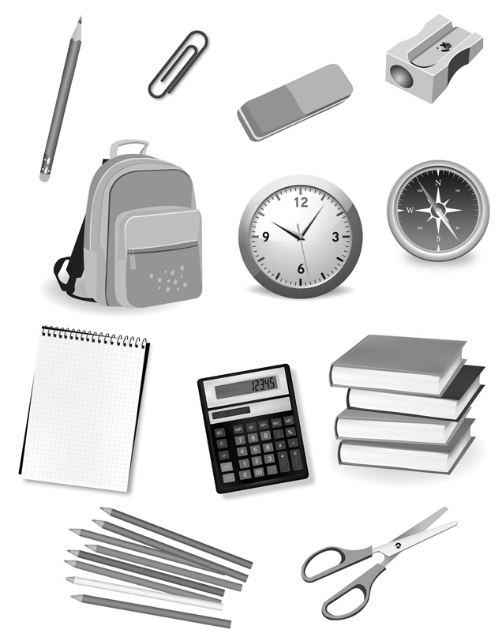
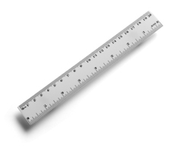
- Match the words with the pictures.
b
a
- clock
d
c
- pencil
- school bag
- rubber
- books
e
- pencil sharpener
g
- paper clip
f
- ruler
- calculator
- coloured pencils
- notebook
- scissors
j
i
h

k
l


- Circle the best option.
Hi, my name is / has got (1) Vanessa and today I am / have got (2) very excited because it’s the first day of school. All my friends is / are (3) there.
I ’m / ’ve got (4) new material for school. I ’m / ’ve got (5) a new school bag. It is / has got (6) blue. This is / are (7) my new notebook. It’s yellow. And my pencil case is / are (8) fabulous. It is / are (9) very big and it is / has got (10) colourful.
I always bring my books and material to school.
Have you got all your material with you?

