Telling the time

- WHAT TIME IS IT? Write the correct time under each picture.

It’s nine minutes past ten. * It’s a quarter to five. * It’s five to twelve. * It’s half past twelve.
It’s four o’clock. * It’s two o’clock. * It’s twenty past eight. * It’s six o’clock. * It’s ten past ten.
It’s ten past three. * It’s twenty-five to eleven. * It’s nineteen minutes past eleven.

Clock(s)
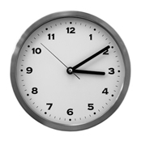
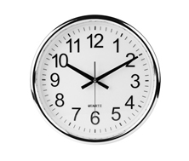
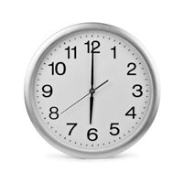
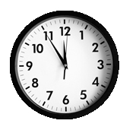
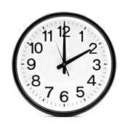

1.____________ 2.____________ 3.____________ 4.____________ 5.____________

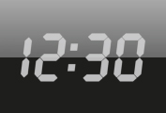
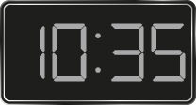
Digital clock(s)
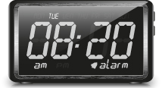
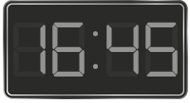

6.______________ 7.________________ 8._______________ 9.________________
Oh, no…
I’m late!

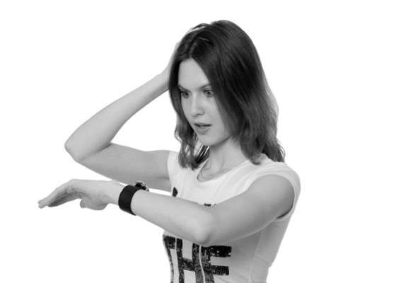
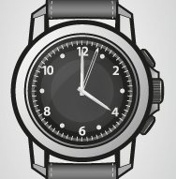
Watch(es)

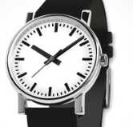
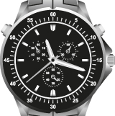

10.______________ 11.________________ 12._______________

