Types of houses

- Unscramble the words and match them with the pictures.
(a)
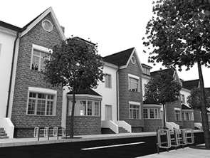
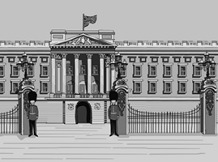
(b)
- lapeca _______________
- golio ________________
- retacerd souhe_________
- meis-tedcahed osuhe____
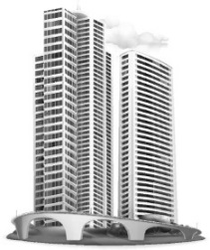
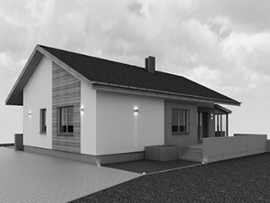
- tafl __________________
(c)
(d)
- hedtadec ehosu ________
- caryskerps ____________
- talces ________________
(f)
(e)
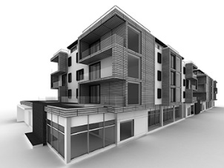
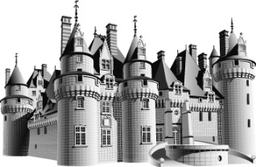
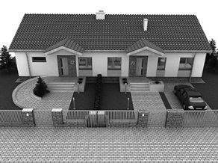
(h)
(g)
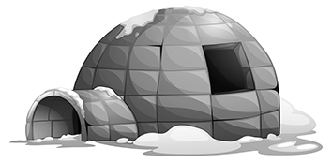


- Where do these people live? Read the texts and write the type of house.

4. I live in a house made of snow but it is not cold. Inside it is warmer than the outside weather.
I live in ______________________________.
2. I live in a house too, that is connected to other two, but I don’t have a garden, just some stairs in front.
I live in ______________________________.
3. I live in a tall building with my mother. I live in the 7th floor. It’s nice because I can’t hear the street noise.
I live in ______________________________.
1. I live in a big house. In front of my house there is a big garden. I haven’t got any neighbours.
I live in ______________________________.

