Parts of the house

A. Look at the picture and complete the crossword. Find out the secret word.
2

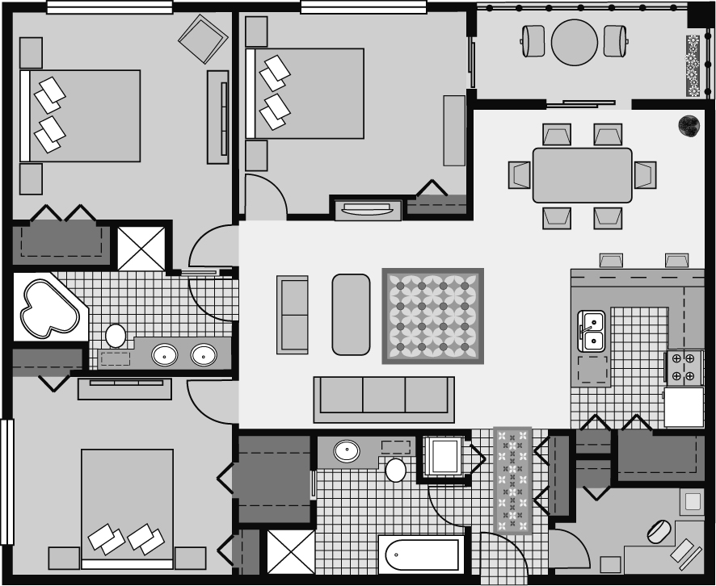
1

5

6

3

4

➔ The secret word is ______________________.

B. Look at the picture above and circle the best option.
 |  |  |  |  |  |  | 1.
 |  |  |  |  |  | 2.
 |  |  |  |  | 3.
 |  |  |  |  |  |  | 4.
 | 5. | D
6.
 |  |  |  |  |  |  |  | O
 |  |  |  |  |  |  |  | M

- In my house there are two / three bedrooms and two / three bathrooms.
- When you get into the house on your right / left there is a study, where I have my computer.
- There is a hall / bathroom between two bedrooms.
- The balcony is next to the living room / dining room.

