Furniture

A. Look at the picture and find the corresponding words in the word search.
5
4
1
2
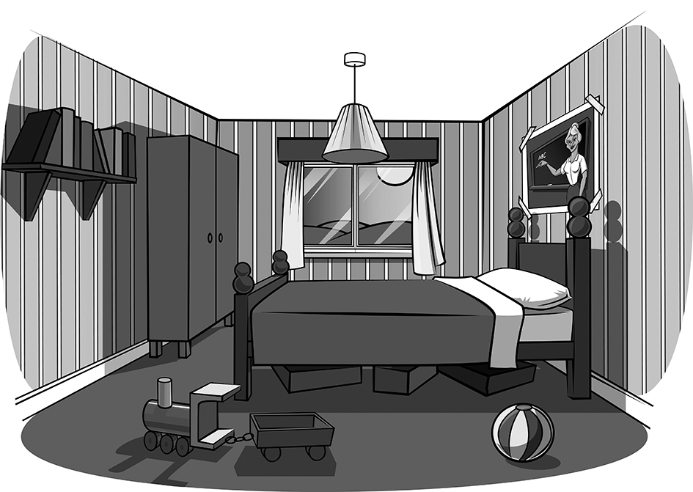
3
7
6

1.____________________
2.____________________
3.____________________
4.____________________
5.____________________
6.____________________
7.____________________

Q | C | U | R | T | A | I | N | S | F | R
A | S | D | F | S | A | T | I | R | E | S
B | O | O | K | S | H | E | L | F | U | P
A | D | W | A | R | D | R | O | B | E | O
W | B | C | A | R | P | T | Y | B | N | M
A | G | E | S | T | P | O | S | T | E | R
L | H | T | D | C | L | O | S | A | V | T
L | M | P | M | A | L | T | O | S | B | A

B. Read the sentences and find out the missing word.

- It’s where we keep our food cool in the kitchen. __ R __ __ __ __
- We have one on the floor of our bedroom. C __ __ __ __ __
- We wash the dishes here. S __ __ __
- It’s where we put our books. B __ __ __ __ __ __ __
- We can sit on it to watch TV. A __ __ __ __ __ __ __
- I like to look at it and see myself in the morning. M __ __ __ __ __

