Daily routine

A. Match the verb with the corresponding expression.
- my teeth
- the clothes
- to school
- the dishes
- the table
- my homework
- the floor
- the dog
- breakfast
- vacuum
- lay
- do
- iron
- wash
- go
- brush
- have
- feed

B. Write the expressions above under the correct picture.
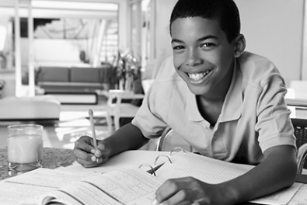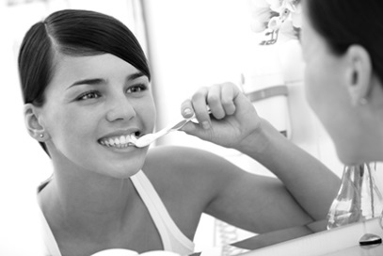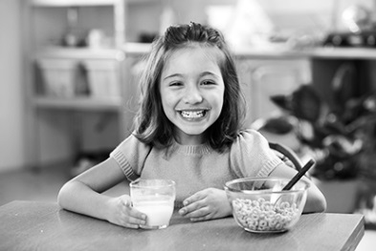
1.____________________ 2.____________________ 3. ____________________
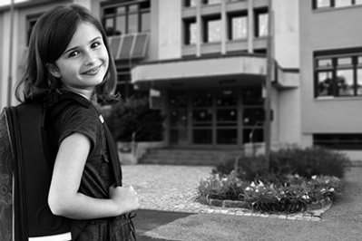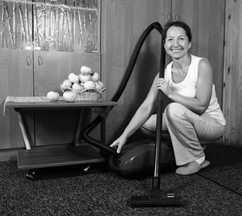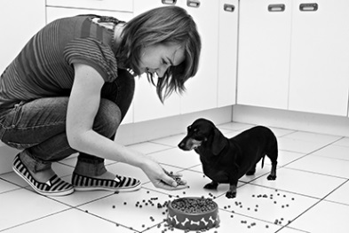
4. ____________________ 5. ____________________ 6. ____________________

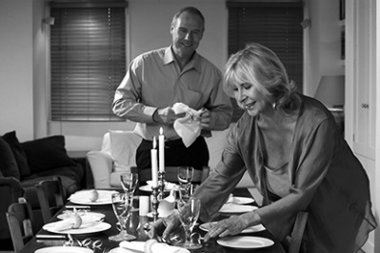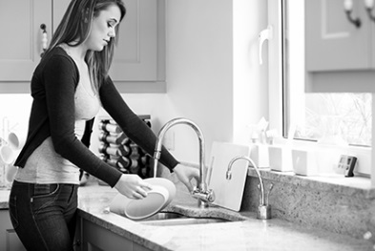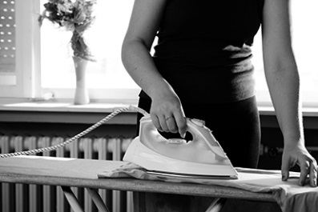
7. ____________________ 8. ____________________ 9. ____________________

