Shops


- Mary went shopping in town. She spent the whole day at the shops. Put the following items in the correct shop.
boots ● ring ● bath products ● bike ● hair products
balls ● jacket ● skirts ● trousers ● necklace ● belt
skateboard ● cosmetics ● vitamins & supplements
flip-flops ● whistle ● earrings ● cardigan ● trainers

SHOE SHOP | SPORTS SHOP | CHEMIST’S | ACCESSORY SHOP | CLOTHES SHOP
____________  ____________  ____________  ____________ | ____________  ____________  ____________  ____________ | ____________  ____________  ____________  ____________ | ____________  ____________  ____________  ____________ | ____________  ____________  ____________  ____________

- In which shop could you hear these sentences?
a. sports shop
b. pet shop
  - We have a huge shopping list. It’s better to get a trolley.
  - Look at those dogs! So cute! Let’s buy one!
c. supermarket
  - I’d like to see that ball and those trainers, please.
d. record shop
  - We’d like some bread and croissants, please.
e. florist’s
  - The CDs are on the left, near the window.
f. butcher’s
  - I’ve ordered some flowers for Mother’s Day.
g. baker’s
  - I’d like two kilos of steak, please.

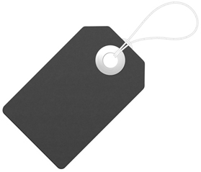
- Read the labels and fill in the table.
T-shirt
100% cotton
Blue
Medium
Made in China
sandals
100% leather
Black
38
Made in Portugal

ARTICLE | MADE OF | MADE IN | COLOUR | SIZE

