At the restaurant / Leisure facilities

A. Complete the menu with the words/expressions in the box.
drinks desserts accompaniments vanilla pudding starters
fruit juice tagliatelle with meatballs main courses


Delicious food!
(1)_______________ |  | (2)________________
- Pâté  - Risotto with Mozzarella  - Spinach with bacon dressing  - Grilled peach salad with grapefruit vinaigrette |  | - Chicken curry  - Pork stew  - (3)__________________  - Seafood risotto  - Mushroom pie
(4)____________ | (5)_____________ |  | (7)_____________
- Chips  - Masala chips  - Boiled rice  - Salad | - Cheese cake  - Victoria Sponge cake  - Pear crumble  - Chocolate trifle  - (6)_________________ |  | - Water  - Lemonade  - Coke  - (8)_____________  - Red wine

B. Complete this conversation with the expressions in the box below.
mushroom pie Delicious Food anything to drink you like to order now
menu any dessert How much is it Thank you very much I’d like

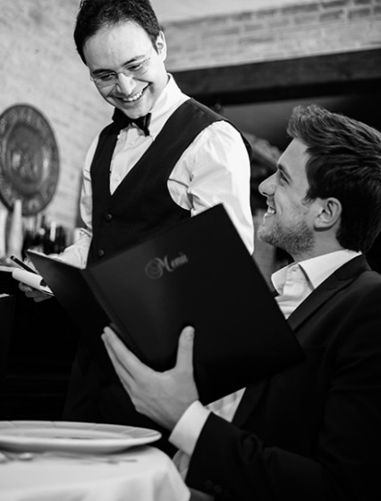
Waiter: Hello! Welcome to (1)______________________?
Here is the (2) ______________________.
You: (3) ______________________.
Waiter: I’ll be back in a few minutes to take your order. (…)
Waiter: Would (4) ______________________?
You: Yes, please. (5) ______________________ a risotto with
Mozzarella.
Waiter: And as a main course what would you prefer?
You: A (6) ______________________, please.
Waiter: Would you like (7) ______________________?
You: Yes, red wine, please.
Waiter: Alright. Later, would you like (8) ______________________?
You: Yes, I’d like a Victoria Sponge cake, please.
Waiter: Okay. I’ll be back with your order. (…)
You: Excuse. I’d like to pay. (9) ______________________?
Waiter: That’s £35, please!

