Public facilities

- Where do you go if you…?
e.g. … want to see paintings and art? To the art gallery.
- … want to catch a train? ________________________________________
- … need to travel with a plane? ___________________________________
- … want to learn new things? ____________________________________
- …want to have fun and go on wild rides? ___________________________
- … need to cross to the other side of the river?________________________

- Read the following sentences and say where these people are.

- Oh no! Please wait for me! I missed it! __ __ __ S __ __ __
- Look, this chair is from the XV century. It’s so old! __ U __ __ __ __
- So you are having high fever lately. Let me see! __ __ __ P __ __ __ __
- Come on… run faster… Let’s go! __ __ R __

- Which sign (A-H) says this (1-8)? Write the letter next to the corresponding sentence.
(d)
(a)
(c)
(b)
Fun rides Park
This week only
Free entrance
9 am – 2 pm
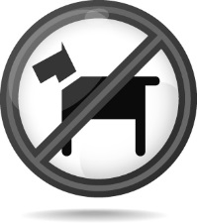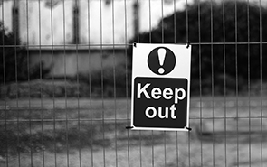
(h)
(f)
BUS STATION
City bus leaves from this stop
every 15 minutes

You must buy tickets before getting on the bus

Park
Under 12s playground

(g)
(e)
Amusement Park
Slides and swings are
for children under 10 only
Relax Zone: Park
No cycling or playing football please

- You are not allowed to ride your bike here.
- You should not enter here. Restricted area.
- Children can play in this place.
- You should not travel on this unless you paid for your journey.
- You won’t have to wait longer than a quarter of an hour to go on this.
- No dogs allowed in this area.
- If you go this Monday you don’t have to pay.
- You should not play on these unless you are younger than ten years old.

