Giving directions / Public signs

- Match the signs with the corresponding meaning.
(c)
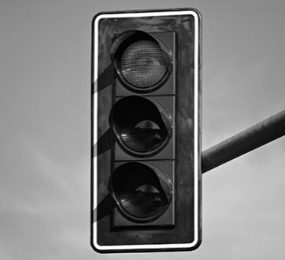
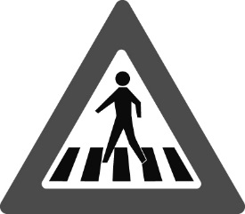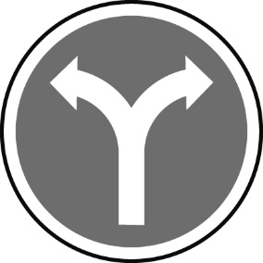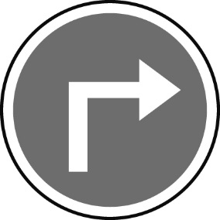
(g)
(f)
(d)
(a)
(b)
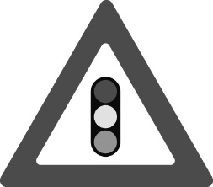
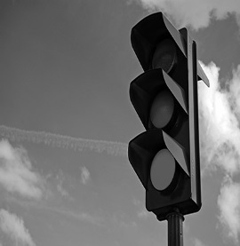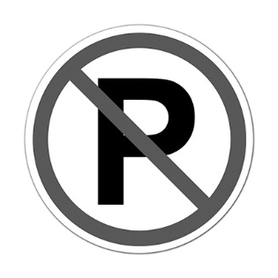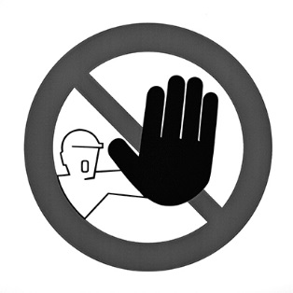
(j)
(i)
(h)
(e)
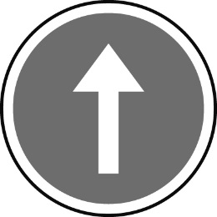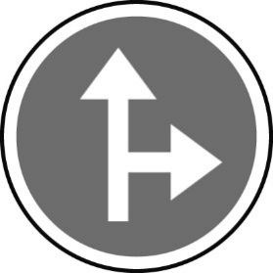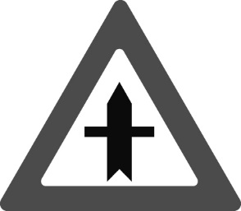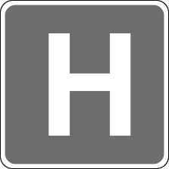
(l)
(k)

- One-way street.  - You must stop and wait.  - Go straight or turn right only.  - You mustn’t enter.  - Traffic lights ahead.  - You must stop for the pedestrians. | - You must turn right.  - Crossroad.  - Hospital nearby.  - You can turn right.  - You mustn’t park here.  - You must slow down and be careful.
B. Complete the following dialogue.

A: Excuse me can (1) _________ _________ _________ _________ the museum is?
B: Yes, it’s on Market Street.
A: How (2) _________ _________ _________ there?
B: Well, (3) _________ _________ ahead and then take the second (4) _________ __________ ________ left. The museum is between the post office (5) _________ the bank.

