Means of transport

- Read the sentences and find in the name of the means of transport. Write the correct words under each picture.
- You can catch it at the railway station. It has many carriages.
- A large vehicle that can travel under water.
- A public vehicle used by many people. It’s cheap to travel on this means of transport.
- A flying vehicle with wings.
- A powerful motor vehicle with two large and two small wheels used on farms.
- The most common vehicle used in cities for a small number of people (1-5).
- A car with a driver who you pay to take you somewhere. Americans call it a cab.
- A vehicle with two wheels that you ride by pushing the pedals.

 |  |  |  |  |  |  |  | T
 |  |  |  |  |  | 1 |  | R |  |  |  | 8
 |  |  |  |  |  |  |  | A
2 |  |  |  |  |  |  |  | N
 |  |  |  |  | 3 |  |  | S
 |  |  |  |  |  |  | 4 | P
 |  | 5 |  |  |  |  |  | O
 |  |  |  |  | 6 |  |  | R
 |  |  |  |  |  |  | 7 | T | A | X | I
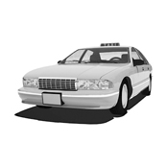
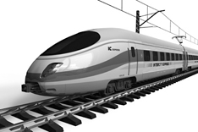
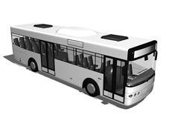
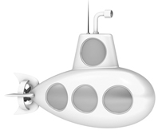

a.______________ b.______________ c.______________ d.______________
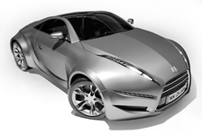
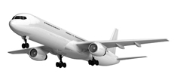
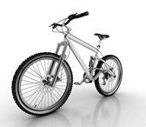
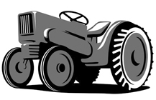

e.______________ f.______________ g.______________ h.______________

- Read the sentences and choose the best option.

- I go to school _______________ every day.
a) on walk b) on foot c) at foot
- João likes to _______________ his bike with his friend Paulo.
a) ride b) go c) drive
- Hurry up! We have to _______________ the bus. It’s just about to leave.
a) ride b) go c) catch
- Let’s _______________ a taxi. It’s quicker than the bus.
a) ride b) take c) drive
- My father _______________ his car to work every day.
a) rides b) catches c) drives
- Oh, it’s too late to _______________ the train to Lisbon.
a) ride b) take c) drive

