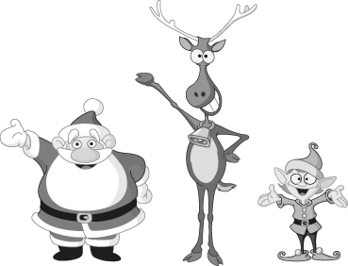
Christmas

- Christmas jokes. Match the question with the right answer.

- What do elves learn in school?
- Why was Santa’s little helper depressed?
- What kind of bird can write?
- What do snowmen eat for breakfast?
Santa Claus
reindeer

elf

- What do you call people who are afraid of Santa Claus?

- “Small world, isn’t it?”
- Claustrophobic.
- Black mail!
- Because he had low elf esteem.
- The Elf-abet!
- The letter “D”.
- It’s Christmas, Eve.
- Ig-“glue”.
- Snowflakes.
- A PENguin.
- What did Adam say on the day before Christmas?
- What do you have in December that you don’t have in any other month?
- What do you call a letter sent up the chimney on Christmas Eve?
- What do Eskimos use to hold their homes together?
- How do elves greet each other?

- Complete this Christmas song.
stocking wish presents happy true tree Christmas thing

Mariah Carey – “All I Want for Christmas is You”
I don’t want a lot for (1)____________  There’s just one (2)____________ I need  I don’t care about the (3)____________  Underneath the Christmas (4)____________  I just want you for my own  More than you could ever know  Make my (5)____________ come true  All I want for Christmas is... You  I don’t want a lot for Christmas  There’s just one thing I need | I don’t care about the presents  Underneath the Christmas tree  I don’t need to hang my (6)____________  There upon the fireplace  Santa Claus won’t make me (7)____________  With a toy on Christmas day  I just want you for my own  More than you could ever know  Make my wish come (8)____________  All I want for Christmas is you  You baby…

- Go online and find all kinds of Christmas songs. Enjoy!
http://xmasfun.com/lyrics.asp

