Easter

- Read the following text about Easter and fill in the gaps with the words given.
symbol resurrection game word world century believed find
BRIEF HISTORY OF EASTER
Easter is a Christian celebration commemorating the (1)____________ of Jesus Christ. Easter is actually an English (2)____________ which some believe comes from the name of the Anglo-Saxon goddess of Spring Eostre.

EASTER EGGS AND THE EASTER BUNNY
The Easter egg is a (3)____________ of fertility and new life which dates back to the 13th (4)____________. Easter eggs are decorated differently throughout the (5)____________. A common (6)____________ kids love to play at Easter is to go on an egg hunt. Coloured eggs are hidden and the children have to (7)____________ them and collect as many as they can.
It is (8)____________ that the symbol of the Easter Bunny was brought to America from Germany. The Easter bunny is also a symbol of rebirth and fertility.

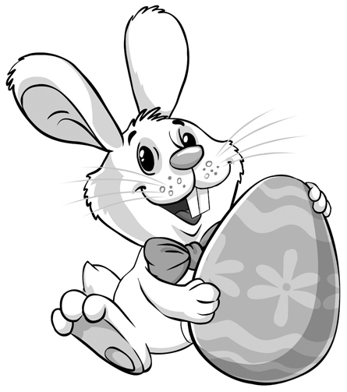

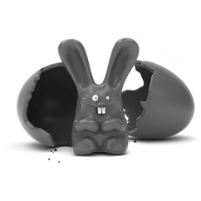

- Find the missing words of the poem in the wordsearch.

I got a (1) c______________ rabbit
For an Easter treat,
A great big chocolate rabbit
Good enough to (2) e______________.
A | S | B | U | C | P | V | B | C
E | A | S | T | H | L | K | N | A
B | Q | W | L | O | V | E | D | T
U | R | E | U | C | F | G | H | U
N | T | A | N | O | T | H | E | R
O | Y | U | J | L | X | C | V | I
S | U | N | D | A | Y | A | S | T
E | S | W | E | T | C | H | O | P
A | C | H | I | E | A | T | C | O

So I ate his ears on (3) S______________,
His nose I finished on Monday.

Oh, I (4) l______________ my chocolate rabbit
From the moment that he came,
And if I get (5) a______________ one,
I’ll love him just the same.

