4th July

- Read this text and write the underlined words under the correct picture.

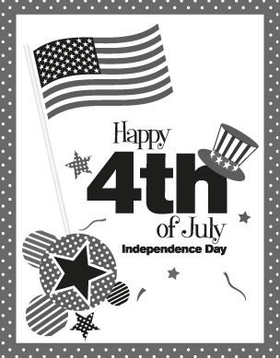
Independence Day, commonly known as the Fourth of July, is a holiday in the United States which commemorates the adoption of the Declaration of Independence on July 4, 1776, which declared independence from the Kingdom of Great Britain.
Independence Day is a national holiday in the United States.
It is commonly associated with fireworks, parades, barbecues, carnivals, fairs, concerts, baseball games, family reunions, political speeches and other ceremonies.
The Fourth of July is the perfect time to gather friends and family for an annual event to celebrate the country’s “birthday”. It is the perfect occasion for an outdoor picnic, pool party, or beach gathering. With beautiful summer weather, the Fourth of July is the perfect excuse to get outside.
(Adapted from: http://en.wikipedia.org)

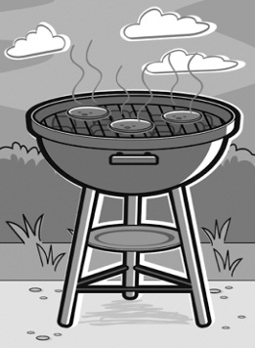

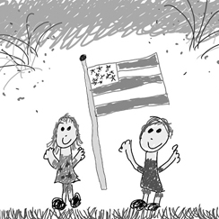

1. ___________________ 2. ___________________ 3. ___________________





4. ___________________ 5. ___________________ 6. ___________________

