Verb to have (got) – Present Simple (affirmative/negative)

- Write have got or has got.
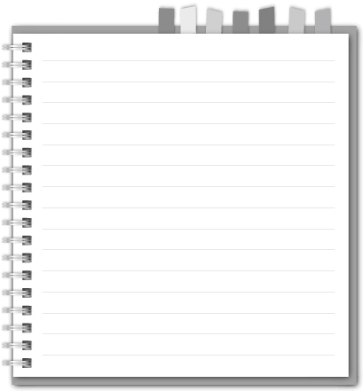

REMEMBER!

I / you / we / they

have got

he / she / it

has got
- I ____________ brown hair.
- My father ____________ a new car.
- Peter ____________ a bike.
- She ____________ blue eyes.
- They ____________ long brown hair.
- Susie ____________ a brother.
- He ____________ a dog.
- My parents ____________ brown eyes.
- My dog ____________ a long tail.
- I ____________ green eyes.

- Rewrite these sentences using the verb have got.
e.g. That’s my car. I’ve got a car.
That’s Susan’s bike. Susan has got a bike.
- That’s Peter’s school bag. .
- That’s my parents’ new car. .
- That’s John’s MP3. .
- That’s Sylvie’s cat. .

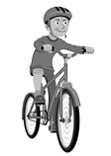
- Look at the pictures and write sentences in the affirmative and negative.
e.g. Matthew / computer / bike
Matthew hasn’t got a computer.
He has got a bike.

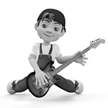
- Matt / a piano / a guitar
_________________________________________________
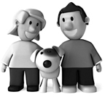
_________________________________________________
- Tina and Ben / a cat / a dog
_________________________________________________
_________________________________________________

