Verb to have (got) – Present Simple (interrogative)

- Complete the dialogue.

Tim Have you got blonde hair? (blonde hair)
Ruth No, I haven’t. (x)
Tim 1. ________________________________? (brown hair)
Ruth __________________________________ ()
Tim 2. ________________________________? (short hair)
Ruth __________________________________ (x)
Tim 3. ________________________________? (long hair)
Ruth __________________________________ ()
Tim 4. ________________________________? (brown eyes)
Ruth __________________________________ ()



- Look at the pictures and write questions and answers.

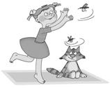
e.g. Rick / computer
Has Rick got a computer?
Yes, he has.
2. Poppy / a cat
___________________________________?
___________________________________


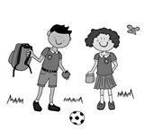
1. Karen / a phone
___________________________________?
___________________________________
3. They / a ball
___________________________________?
___________________________________

- Match the questions with the answers.

- Have you got any brothers or sisters? |  | - Yes, I have. I’ve got a white cat.
- Has Peter got blue eyes? |  | - Yes, they have.
- How many dogs have you got? |  | - Yes, we have. At ten o’clock.
- Have you got a pet? |  | - No, I haven’t. I’m an only child.
- Have they got pens? |  | - Yes, she has.
- Have we got Maths today? |  | - No, he hasn’t.
- Has Kate got long hair? |  | - Yes, I have.
- Have you got a computer? |  | - Three. Two Golden Retrievers and a Rottweiler.

