Family

A. Fill in the table with the missing words.

MALE | FEMALE |  | INDIVIDUAL | COLLECTIVE
1. | grandmother |  | 9. grandfather + grandmother
2. father |  |  | 10. father + mother
3. | sister |  | 11. grandson + granddaughter
4. uncle |  |  | 12. son + daughter
5. | wife |  | 13. brother + sister | brothers + sisters
6. son |  |  | 14. uncle + aunt | uncles + aunts
7. | cousin
8. nephew

B. Look at Sophie’s family tree. Complete the sentences.
- Mary is Paul’s _________________.
- Margaret and Jim are Mary and Paul’s _____________.
- Paul is Lisa’s __________________.
- Lisa is Sophie’s ________________.
- Rebecca is Paul’s ______________.
- Jim is Margaret’s __________________.
- Josie is Margaret’s ________________.
- Mark is Josie’s ___________________.
- Matthew is Josie and Paul’s _________.
- Matthew and Anne are Sophie’s
____________________.
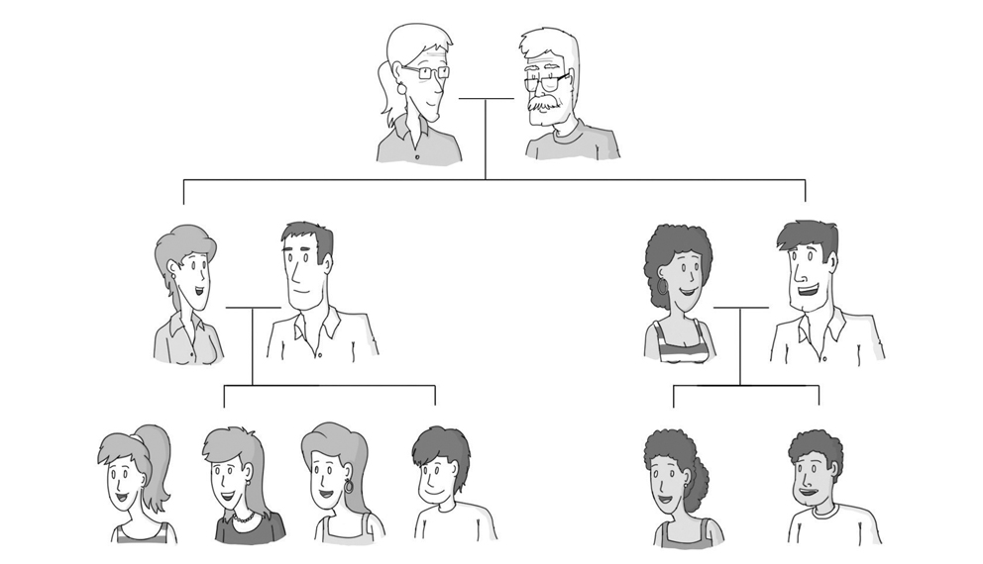
grandfather
grandmother
Me!
cousins
brother
sisters
uncle
aunt
father
mother
Jim
Margaret
Mark
Lisa
Rebecca
Sophie
Paul
Mary
Kevin
Josie
Anne
Matthew

