Verb to have (got) and verb to be

- Circle the best option.
My name (1) is / has got Margaret. I (2) am / have got 38 years old. This (3) is / has got my husband, Billy. He (4) is / has got from France, but I come from Angola. We (5) are / have got both teachers. We (6) are / have got two children, a girl and a boy. Our girl’s name (7) is / has got Lisa and our boy’s name (8) is / has got Eddie. They (9) are / have got great kids! Lisa (10) is / has got twelve years old and Eddie (11) is / has got fourteen.


- Complete the sentences with the verb to be or to have (got).
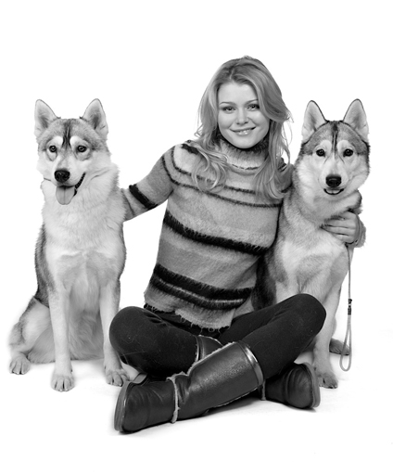
- I __________ two dogs. Their names __________ Bobby and Rex.
- My sister __________ short curly hair.
- My mother’s eyes __________ blue.
- Jonathan __________ ten years old.
- She __________ from Venezuela.
- Peter __________ a camera.
- They __________ my brothers.
- Jack __________ Italian.
- My parents __________ forty years old.
- My new bike __________ blue.

- Read the sentences. Underline the mistakes and correct them.

e.g. My mother are a doctor. My mother is a doctor.

1. Peter have got a new bike. ________________________________.
2. Paul and Zack is Italian. ________________________________.
3. Sylvie has got 12 years old. ________________________________.
4. I am a big piano at home. ________________________________.
5. I am nice T-shirts. ________________________________.

