Present Continuous (1)

- Look at the pictures. Read the sentences below and write them under the correct picture.






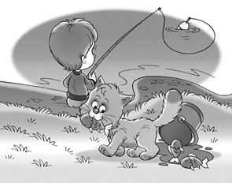


1._____________ 2.____________ 3.___________ 4.____________ 5.__________

6._________________ 7. _________________ 8. _________________
Tony and Cathy are singing. Ted is fishing.
Michael is playing with his plane. Tina is laughing.
Matt is playing football. Mario and Silvia are cooking.
Anna is crying. Samuel is running.

- Complete the following sentences with the Present Continuous (affirmative).

- Richard _______________ (have) a shower now. He can’t come to the phone.
- Anna _________________ (watch) a film.
- Look, Michael _________________ (play) football over there. Let’s talk to him.
- The baby _________________ (sleep) now. Don’t make so much noise.
- Look at all those people over there. I don’t know what _________________ (happen).
- They _________________ (run) around the park.
- At the moment I ______________ (read) a book about vampires. It’s fantastic!
- Oh no! It _________________ (rain)!
- Where are Paul and Kate? They are over there. They _________________ (wait) for the bus.
- I can’t go now. I ____________ (do) my homework.

