Present Continuous (2)

- Look at the pictures and answer the questions.

e.g. Are John and Julie writing?
No, they aren’t.
They’re speaking.

1. Is Susie playing the guitar?
________________________________________
________________________________________


2. Are they playing tennis?
________________________________________
________________________________________
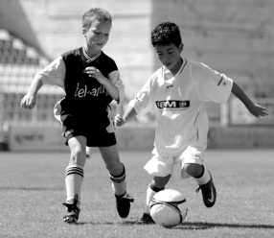

3. Is she eating an ice cream?
________________________________________
________________________________________


4. Are you dancing?
________________________________________
________________________________________


- Match in order to make complete sentences.
- because he has a test tomorrow.
- on the phone.
- because he’s thirsty.
- because he’s tired.
- and sending emails to her friends.
- my mother is cooking dinner.
- Michael is drinking water
- Philip is studying
- Annie is writing on her computer
- Paul is sleeping
- Rachel is talking to her mother
- While I’m doing my homework

