Possessive adjectives and pronouns
It’s mine.
I have got a cat.
It is my cat.
Whose cat is this?
PERSONAL PRONOUNS | POSSESSIVE DETERMINERS | POSSESSIVE PRONOUNS
I | my | mine
you | your | yours
he | his | his
she | her | hers
it | its | its
we | our | ours
you | your | yours
they | their | theirs
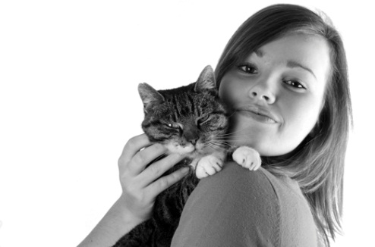
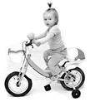



- Fill in the blanks with the correct possessive adjective. Then match the sentence with the correct picture.
e
d
c
a
- Susan has got a bike. It’s ________ bike.
- Toby has got a puzzle. It’s ________ puzzle.
b

- They have got a son. He’s ________ son.
- I have got a laptop. It’s ________ laptop.
- We have got presents. They’re ________ presents.

- Write questions and answers.
e.g. pencil / I Whose pencil is this? It’s mine.

- pen / he _________________________? ____________________.
- computer / she _________________________? ____________________.
- dog / they _________________________? ____________________.
- book / your _________________________? ____________________.

- Circle the correct option.

- That is not your / yours pen. It’s my / mine.
- Where is my / mine pencil case?
- This is their / theirs problem, not my / mine.
- They have got three children, but I don’t know their /theirs names.
- My / Mine bike is bigger than her / hers.
- I can’t find my / mine pencil. Can I use your / yours?

