Animals: pets

- Look at the pictures and complete the crossword with the name of the animals.
 |  |  |  |  |  | 1
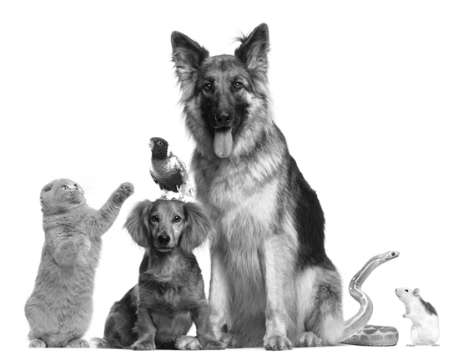  7 |  |  |  | 2
 |  |  | 3
4
6
2 | 5 |  |  |  |  |  | 7
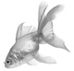 |  |  | 6
5
4
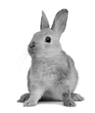
3
1

- Read the text and complete the chart.
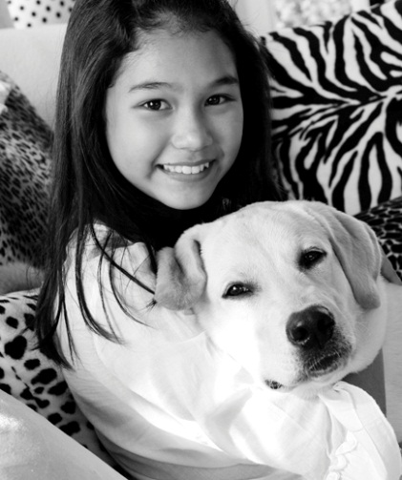
Hi! My name is Thelma. I’m eleven years old.
I love animals. I’ve got a dog. His name is Rex and he is light brown. I’ve also got a parrot. He’s called Bling. He’s blue and yellow. Oh… and I have got an aquarium with two fish. They are orange and green. They are very beautiful. Their names are Splish and Splash.
And you? Have you got any pets?

PET | NAME | COLOUR

