Verb to be / to have got – Past Simple

- Complete the sentences with the correct form of the verb to be in the Past Simple.
- The weather _______ really good last week.
- Bob and Patrick _______ here on holiday. They _______ in Paris.
- When I _______ on holiday in Africa, I _______ (negative) afraid of snakes. I used to play with them.
- The hotel in Paris _______ very comfortable but it _______ too expensive. I hated it.
- Sarah _______ (negative) at the gym yesterday. Where _______ she?
- “Why _______ you late this afternoon?” “Because the traffic _______ bad. Sorry.”
- They _______ at the football match last weekend but they _______ (negative) too excited.
- I _______ happy with what I read on the newspaper. Good news!
- My parents _______at the cinema yesterday. And you? _______ you there too?
- We _______ so happy at the concert but it _______ so cold there.

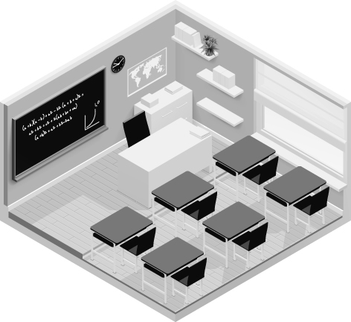

- Complete the text with the Past Simple of the verb there to be: affirmative or negative.
Look at my classroom four years ago. Now it is completely different.

Hi, I’m Jane Li. This was my classroom in China. (1)__________ six tables and six chairs. It was a small class. There were only nine students. (2)__________ one desk for the teacher and (3)_____________ a blackboard. (4)______________ a projector and (5) _______________ any computers.
(6)____________ a clock on the wall. (7)_____________ a bookcase with books in it. On the wall (8)____________ a world map. I liked my classroom but now it has got computers.

