Past Simple – negative

- Complete the sentences with the verbs in brackets in the Past Simple – negative.

- I _______________ (brush) my teeth last night. I forgot to brush them.
- I _______________ (clean) my bedroom yesterday. Mum, I’m so sorry!
- Tony _______________ (have) his breakfast this morning, that’s why he’s hungry.
- You _______________ (send) me the email. Did you forget?
- When I went to Paris I _______________ (see) the Eiffel Tower. What a shame!

- Rewrite the following sentences in the negative form.

- Yesterday I ate Mexican food.
____________________________________________________________________
- Michael bought a new computer game.
____________________________________________________________________
- He took a taxi to the airport.
____________________________________________________________________
- I invited a lot of friends to my house.
____________________________________________________________________
- Last weekend I played football with Jack.
____________________________________________________________________

- Rewrite this text in the negative form.
Yesterday I was very happy! I had a good mark in the English test. I went to my friend’s house and we played all afternoon after school. I ate my favourite food with my family. In the evening I did all my homework very quickly. At night I watched my favourite TV show and, then, I slept all night long.
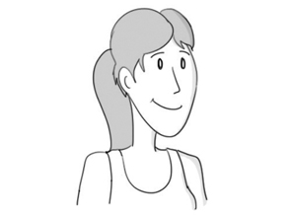

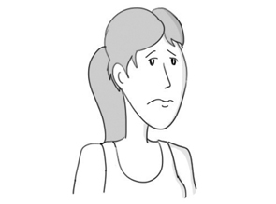
Yesterday I ______________________________________________
__________________________________________________________________________________________________________________________________________________________________________________________________________________________________________________________________________________________________

