Modal verbs

- Look at the pictures and match them with the sentences.
d
c
b
a
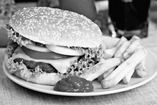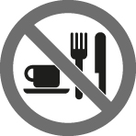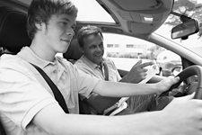

- You must drive carefully.
- You should go to the dentist.
- You shouldn’t eat so much fast food.
- You mustn’t eat in here.

- Circle the best option.

- I will / won’t visit my aunt in London next weekend. She is ill.
- You should / shouldn’t play football in the road. It’s dangerous.
- Passengers must / mustn’t smoke anywhere on the train.
- In Portugal, you must / mustn’t be eighteen to vote.
- I’m not sure… I will / might be late for the concert.
- May / Must we come a bit later tonight, please? It’s Carl’s birthday.
- Liz can / can’t use a computer, so she’s having computer lessons.
- You might / mustn’t see me tonight at the party. I’m not sure yet!
- Helen should / shouldn’t eat so much sugar. She has diabetes.
- We should / shouldn’t recycle.

- Complete the sentences with the correct modal verb.
should shouldn’t must mustn’t might won’t will may

- OBLIGATION  Sam, you ________ be quiet. We are in a library.
- ADVICE  You ________ go out tonight. You have to study for the test tomorrow.
- ADVICE  It looks like it’s going to rain. You ________ take your umbrella.
- PERMISSION  Mum, ________ I go to the cinema today?
- PROHIBITION  People ________ use their mobiles phones when driving.
- FUTURE POSSIBILITY  I’m not sure… She ________ be at home by now.
- PROMISE  I ________ tell lies anymore! I promise you!
- CERTAINTY  I’m feeling better now. I ________ see you tomorrow at school.

