Comparative adjectives
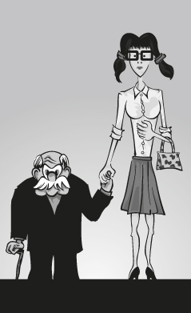
- Look at the picture and write BOB or JESSICA.

- _______________ is shorter than _______________.
- _______________ is taller than _______________.
- _______________ is thinner than _______________.
- _______________ is older than _______________.
- _______________ is younger than _______________.

- Choose the best option.
Jessica
Bob

- A gold ring is ____________________ than a silver ring.
a) expensive b) expensiver c) more expensive
- A tennis ball is ____________________ than a golf ball.
a) biger b) bigger c) more big
- John is ____________ Michael , they have the same age.
a) older than b) as old as c) less old than
- I’m a good student, but João is ____________________.
a) gooder b) more good c) better
- I think Mary is pretty, but Rachel is ____________________.
a) prettyer b) prettier c) more pretty

- Put the words ir order to form sentences. Then match each sentence with the correct picture.
- mouse / than / a / An / is / elephant / bigger
An ____________________________________________________________
- hare / A / a / tortoise / slower / is / than
A _____________________________________________________________
- is / than / faster / My / my / one / bike / new / old
My ____________________________________________________________
- Susan’s / fashionable / Rachel’s / are / more / clothes / than
Rachel’s _______________________________________________________



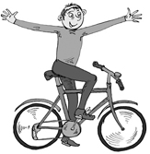
d
c
b
a

