Compound nouns

- Match in order to create compound nouns. Then match the pictures with the word.
glasses board ring brush moon office cream print

(a)
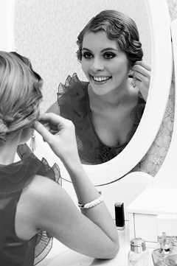
- tooth__________
(c)
(b)
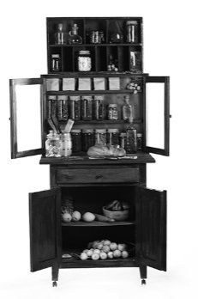

- ice____________
- sun___________
- honey_________
- cup___________
- finger_________
- post__________
(g)
(f)
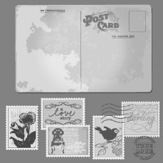
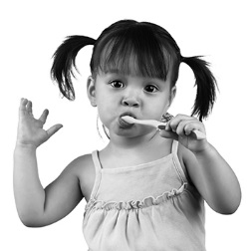
- ear___________
(h)
(e)
(d)


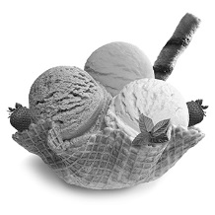

- Complete the sentences with a compound noun from exercise A.

- The police took the suspects’ ___________ to identify the criminal.
- Children’s ___________ cleans upper and lower gums and teeth at the same time.
- More and more couples are choosing a cruise for their ___________ .
- My kitchen ___________ was a present from my lovely grandmother.
- Paula found her lost diamond __________ on her bedroom’s floor.
- My mother bought ___________ and fruit for dessert.
- I often use ___________ to protect my eyes against the sun.
- Yesterday I went to the ___________ to get some stamps.
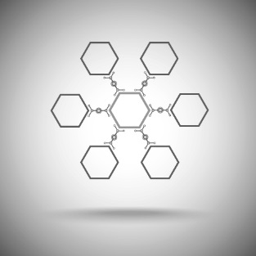
- Read the sentences and write a compound noun as an answer.

- How do we call a shop where books are sold?
_B __ __ __ __ __ __ __

- How do we call a room containing a bath and a toilet?
_B __ __ __ __ __ __ __

