Superlative adjectives

General knowledge quiz.

- Which is the smallest country in the world?
(a) Vatican city (b) Monaco (c) Andorra
- Which is the fastest animal in the world?
(a) the ostrich (b) the cheetah (c) the tiger
- Which is the largest ocean in the world?
(a) the Pacific Ocean (b) the Atlantic Ocean (c) the Indian Ocean
- Which is the biggest planet in the solar system?
(a) Jupiter (b) Venus (c) Earth
- Which is the biggest country in the world?
(a) Russia (b) Canada (c) the USA
- Which is the biggest city in the world?
(a) New York (b) London (c) Tokyo
- Which is the longest river in the world?
(a) the Amazon (b) the Mississippi (c) the Nile
- Which is the largest animal in the world?
(a) the elephant (b) the shark (c) the blue whale

B. Complete the sentences with the superlative form of the adjective in brackets.
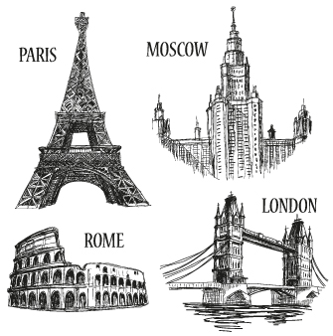
- London is _______________ (large) city in England.
- The Alps are _______________ (high) mountains in Europe.
- That was _______________ (bad) food I have ever tasted.
- John is _______________ (funny) person I know.
- This Italian salad is _______________ (delicious) salad I have ever eaten.
- Mario is _______________ (good) student in my class.
- Today is _______________ (hot) day of the year.
- Paris is _______________ (beautiful) city I have visited!
- The name Tom is one of _______________ (common) names in England.
- I think that Moscow is _______________ (cold) city I’ve ever been to in winter.

