Comparative and superlative

4

A. Choose the appropriate option: comparative or superlative. Then match the sentences with the pictures.

- The new grey sofa is _________ than the old brown one.
a) more comfortable b) the most comfortable
(a)
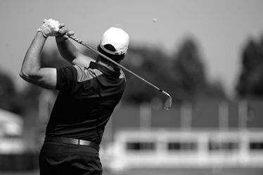
- I bought _________ sunglasses I could afford.
a) more expensive b) the most expensive
3. The television you bought is _________ of all.
a) cheaper b) the cheapest

4. This is _________ restaurant in town.
a) better b) the best
(b)

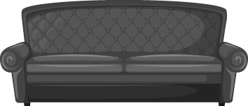
5. I think football is _________ than golf.
a) more exciting b) the most exciting

6. Susan’s house is _________ than mine.
a) bigger b) the biggest

(f)
(e)
(d)
(c)

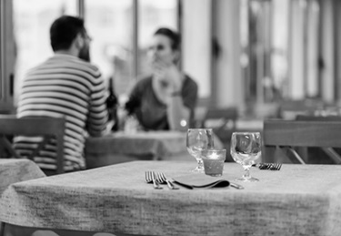
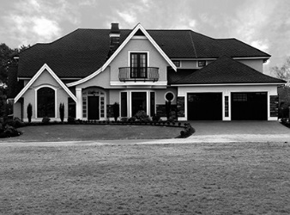


Fill in the gaps with the comparative or the superlative form of the adjectives given.
1. Peter thinks Chinese is ________ (difficult) language in the world.
2. This is the _________ (dirty) kitchen I have ever seen.
3. Yesterday I was rather sad. Today I am _________ (happy).
4. That was a really good meal, probably one of _________ (delicious) I have
ever eaten.
5. I am _________ (good) at Maths than my sister.
6. This fruit salad is ________ (healthy) than the chocolate cake.

