Body parts

- Match the description with the correct picture.
- A big mouth
- A big nose
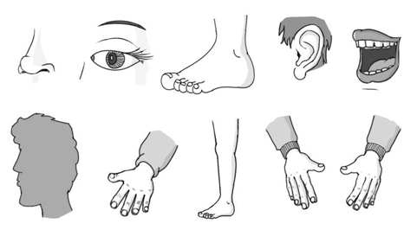
- A little hand

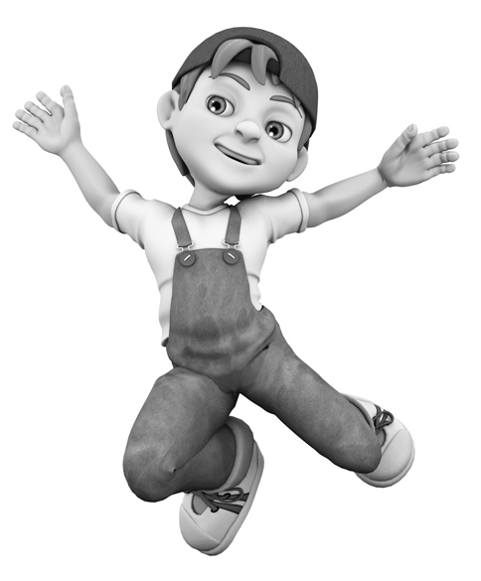
a
b
d
e
c

1
9
f
g
h
i
2
4
3
- Complete the table with the singular / plural.
8
5
6
7
1. ______________________________
2. ______________________________
3. ______________________________
4. ______________________________
5. ______________________________
6. ______________________________
7. ______________________________
8. ______________________________
9. ______________________________
10. _____________________________
11. _____________________________

SINGULAR | PLURAL
1. leg
2. | eyes
3. shoulder
4. foot
5. | heads
6. ear
7. hand
8. | arms
- Complete with numbers.
1. I have _____two_____ legs
2. I have _____________ fingers
3. I have _____________ arms
4. I have _____________ head
5. I have _____________ hands
6. I have _____________ eyes
7. I have _____________ mouth
8. I have _____________ nose

- Look at the picture and label the parts of the body. Use the words below.
leg * mouth * nose * arm * neck * feet
head * ear * eye * hand * knee

10
11

