Prepositions of place
- Mr Brown is confused. He can’t remember what his students’ names are. Help Mr Brown.
Sylvie is in front of Sophie. Tim is behind John. Carol is behind Tim. Bob is next to Carol. Paul is in front of Jackie. Catherine is between John and Michael. Robert is next to Paul. Marion is behind Robert and Michael is in front of Robert.

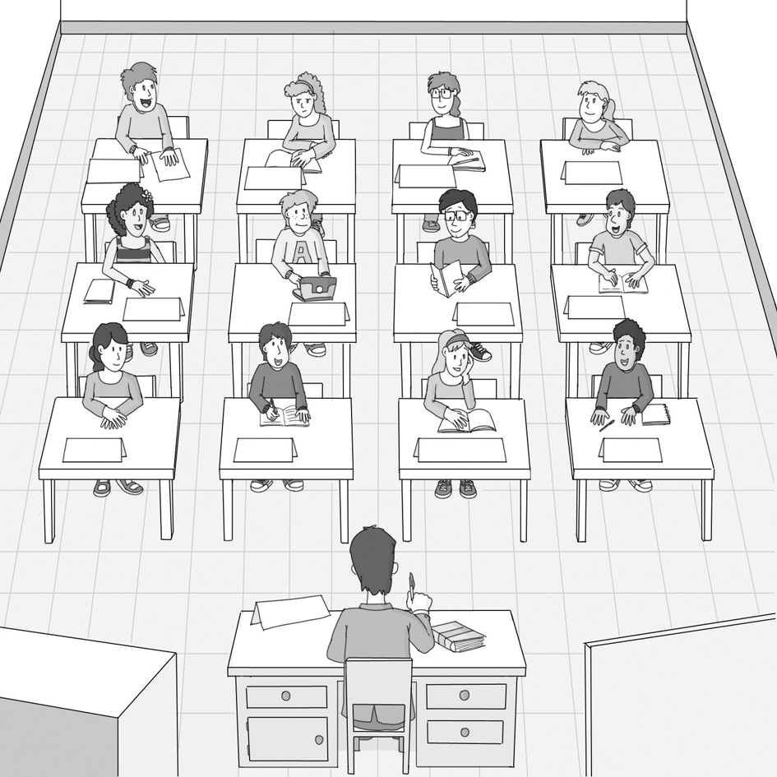

Carol

Sylvie
Catherine

?
?

- Answer these questions about the previous picture. Use the words in the box.
in front of
next to
behind
opposite
between

- Where’s John? He’s _______________ Sylvie and Catherine.
- Where’s Bob? He’s _______________ Sophie.
- Where’s Paul? He’s _______________ Robert.
- Where’s John? He’s _______________ the teacher.
- Where’s Tim? He’s _______________ Carol.

