Past Continuous (1)

Positive | Negative | Questions
      was / were V + ing | wasn’t / weren’t V + ing | (Wh) was/were V + ing

- Write what people were doing at two o’clock yesterday.
- We ______________ (eat) pizza.
- Julio ______________ (listen) to music.
- You ______________ (talk) on the phone.
- Silvia and Martha _________ (watch) TV.
- I ______________ (play) chess with David.
- Jack ______________ (write) an email.
- My mum ______________ (make) a cake.
- They _____________ (clean) their bedroom.

- Complete the following sentences with the Past Continuous.

- At 11 a.m. Tom and Lucy ______________ (shop) in the town centre.
- At 12:30 my sister ______________ (sit) on a bench in the park reading a book.
- Paul ______________ (watch) Amanda while she ______________ (play) the piano.
- While Carl and Mary ______________ (wait) for the bus, it started to rain.
- Rob and Liz ______________ (jog) in the park when I saw them.

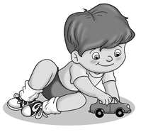
- Look at the pictures and write sentences using the Past Continuous.

e.g. John / run
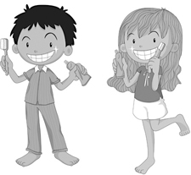
John wasn’t running.
He was playing with his car.

- Michael and Vanessa / have breakfast
_____________________________________________

_____________________________________________

- Pete / watch TV
_____________________________________________
_____________________________________________

