Past Continuous (2)

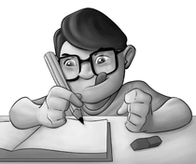
- Write sentences using while.
Stefan / do his homework
His brother / play music really loud


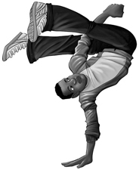
- While ___________________________, ________________________________

David / dance
His mother / bake a cake

- While ___________________________, ________________________________

- There was a bank robbery yesterday. What were they doing when it happened? Look at the picture and answer the questions.
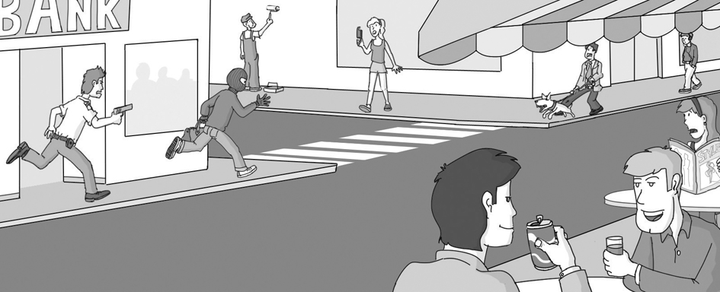
Paul
Sylvie
Mr Smith
Ted

Jill

Ben
John

- What was Paul doing? __________________________________
- What were Ben and John doing? __________________________________
- Was Jill playing computer games? __________________________________
- What was Mr Smith doing? __________________________________
- Was Ted walking his dog? __________________________________
- What was Sylvie doing? __________________________________

