Prepositions of movement

Complete the following sentences with the prepositions of movement below. Then match the pictures with the sentences.
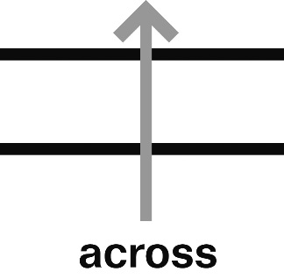
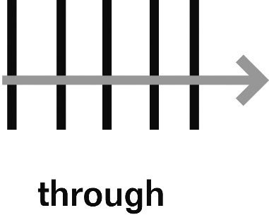
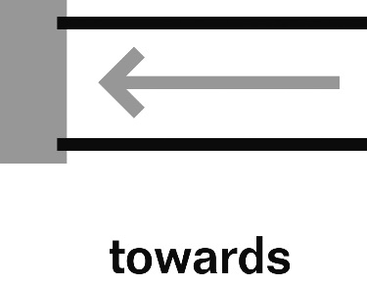

(c)
(b)
(a)

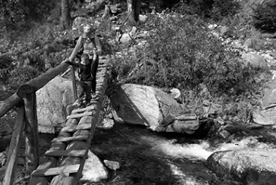
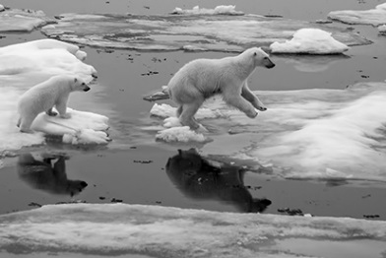


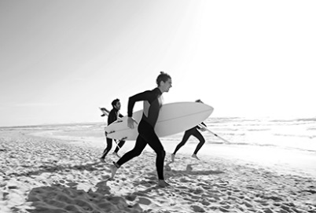
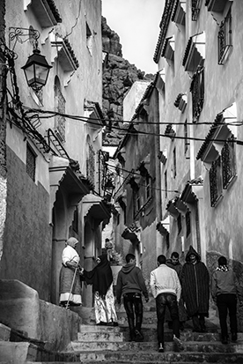
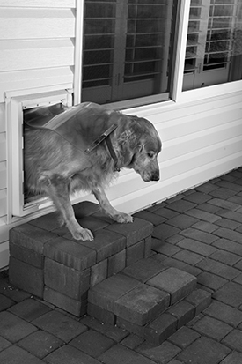
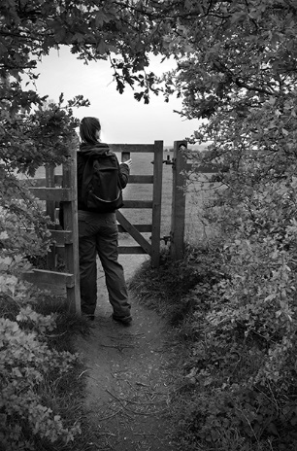
(g)
(f)
(h)
(e)
(d)

- The boys are walking _________ a street in Morocco.
- The polar bears are jumping __________ an ice floe in Norway.
- Little Patty is running __________ her father at the beach.
- Cynthia walks everyday ___________ a wooden gate in the countryside.
- Joseph and Tom are running _________ the sea at the moment.
- The mother is guiding her small son __________ the wooden fridge.
- My boss is now walking _________ his private jet.
- The dog is walking _________ a doggie door.

