Hobbies
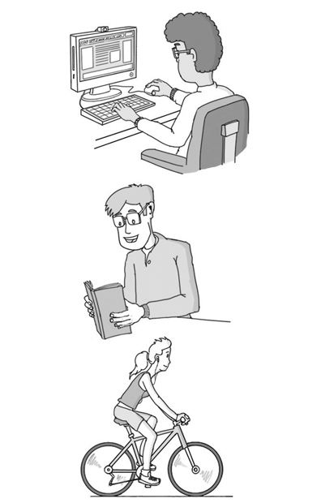
- Match the verbs in column A with words in column B.

Column A |  | Column B
- watch |  | - a bike
- listen |  | - the piano
- surf |  | - a book
- play |  | - TV
- go |  | - a picture
- read |  | - friends
- draw |  | - the net
- solve |  | - photos
- meet |  | - a puzzle
- practise |  | - to music
- ride |  | - shopping
- take |  | - a sport

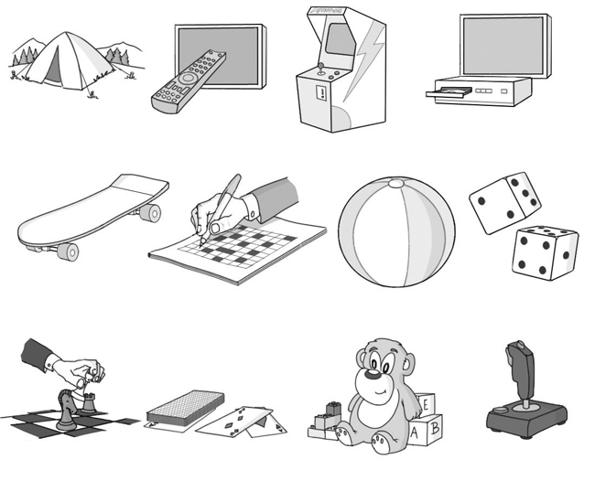
- Look at the list of words related to things we use in our free time. Write the letter next to the right word.

- joystick

- toys
b
a

- remote control
c
d

- DVD
e

- dice

- skateboard

- cards
f
h
g

- tent

- crossword
i
k

- beach ball
j
l

- chess

- arcade machine

