Sports

- Complete the sentences with the words given and write the correct letter next to each sentence.
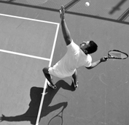
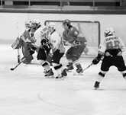


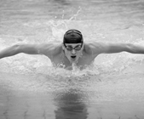

b
e
c
d
a

- Mario is boxing in a boxing .
track
pool
rink
ring
court
- He is playing tennis on a tennis .
- Rita is running on a .
- My team is playing ice hockey on an ice .
- Paul is swimming in a swimming .

- Write the name of the sport under each picture. Use the words from the box.

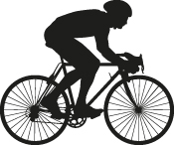  table tennis  diving  water polo  rowing  cycling  running  archery  basketball  weight lifting  1._______________ | 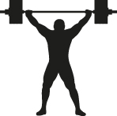  2._______________ |   3._______________
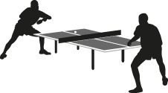  4._______________ |   5._______________ | 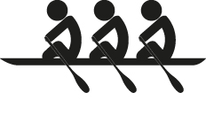  6._______________
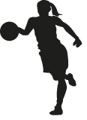  7._______________ | 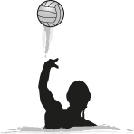  8._______________ | 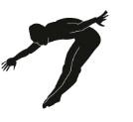  9._______________

- What’s your favourite sport? ________________________________________

