Clothes and equipment

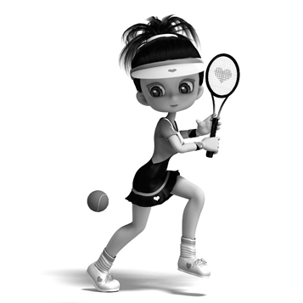
- Write the words in the correct place. Use the words from the box.
T-shirt
socks
trainers
ball
racket
skirt
4.
1.

5.
2.

6.
3.

- Complete the crossword with the names of the clothes.
 |  |  |  |  | 6
1 |  |  |  |  |  |  | 7
 |  |  |  |  |  |  |  |  |  |  | 9
 |  | 2
 |  |  |  |  |  |  |  | 8
3 |  |  |  |  |  | 5
 |  |  |  | 4

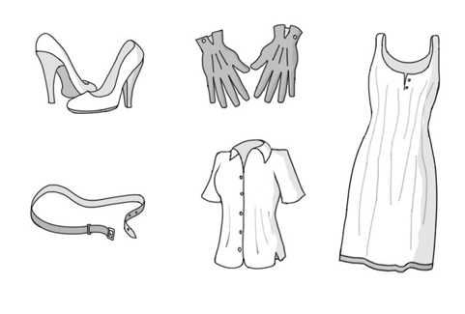
Across Down
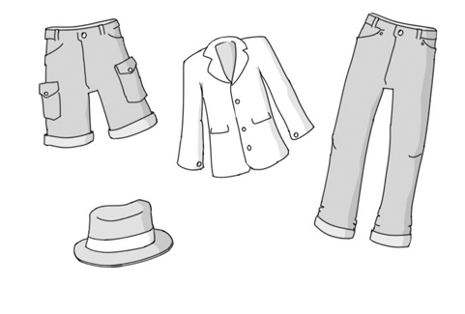
2
3
1
6
4
9
5
7
8

- What are you wearing now? I’m wearing _______________________________

