School subjects

- Circle the best option.

- “Does anybody know who Henry VIII was?”  a) Economics b) History  c) Biology d) Maths | - “One apple and two apples make a total of three apples.”  a) Physics b) Maths  c) Biology d) Science
- If you go to Paris, you will have to speak this language.  a) French b) Italian  c) English d) Spanish | - “Whales are marine mammals that inhabit the oceans.”  a) History b) Chemistry  c) Biology d) Portuguese
- “Let’s play that part of the song one more time, please.”  a) Art b) Dancing  c) Music d) Poetry | - “Run round the school building three times without stopping.”  a) Technology b) Chemistry  c) P.E. d) History
- “What is the highest mountain in the world?”  a) Science b) P.E.  c) Latin d) Geography | - “Repeat after me: I am, you are, he is, she is, it is...”  a) French b) Italian  c) English d) Spanish

- Match the sentences above with the correct pictures.


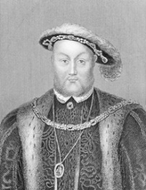


D

C

B
A


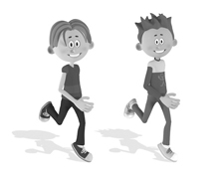



H

G

F
E

