1
Test A
Unit About myself

School: _______________________________________________________________
Name: _________________________________________ Class: ______ No.: ______
Date: ______/______/______ Mark: ______
Enc. Educação: ______________________ Teacher: __________________________

Vocabulary

- Read these sentences. What is the word for each sentence?

- This is my mother’s brother. U ___ ___ ___ ___
- You can write in this at the end of each day. D ___ ___ ___ ___
- A person that was born in Ireland. I ___ ___ ___ ___
- A synonym for “very big”. H ___ ___ ___
- The opposite of sociable. S ___ ___

- Write the words below under the correct heading.
nationality daughter age bird funny
handsome quiet husband good-looking turtle

Identity | Family | Pets | Physical appearance | Personality

- Complete the five conversations.

1. I don’t know your email address. | a. It’s in Kingston street.  b. I can go there.  c. I’ll give it to you.
2. What does your mother look like? | a. She’s funny and kind.  b. She likes classical music.  c. She’s tall and she’s got blonde hair.
3. This is my new puppy. | a. What’s your name?  b. Me neither.  c. Oh, so cute!
4. You look great today! | a. Today is OK.  b. Thanks.  c. Yes, I am.
5. Who’s that? | a. My older sister.  b. In London.  c. That’s my car.

Reading Comprehension

Read the article about a British teenager and his pets.
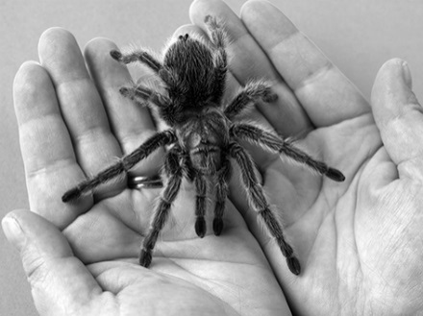
Teenager owns more than 300 exotic pets
Liam Andrews is a teenager that loves animals so much he has over 300 exotic pets! Liam and his parents spend a lot of money in the young animal lover’s hobby, and Liam seems like a very happy kid. Liam, who studies animal management and welfare, has animals that include eight snakes, five scorpions and twelve tarantulas.
Liam Andrews lives in Desborough, Northamptonshire and he started* collecting animals at 6 years old when he asked* his parents if he could* buy a hamster with his pocket money.
Andrews says he “prefers animals to humans. They are friendly and quiet. (…) I have around 60 reptiles and other exotics that sleep in my bedroom with me.”
However, his collection of pets, which cost £8.500 to look after, doesn’t impress his mother, because she fears “what she might find next in his room. (…) Liam is totally obsessed with all his animals… I hate spiders and will never hold one.”
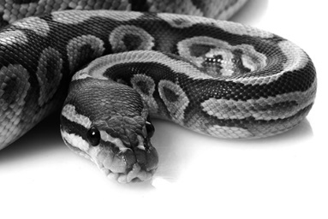
Other creatures in the collection include 30 giant African land snails, 100 tropical fish and one tomato frog. Andrews thinks that it’s amusing to have so many exotic animals around him. He says his favourite animal is his 6ft-long python called Monty, who likes to watch TV and go shopping with him.
My dictionary:

started começou
asked perguntou
could podia

Phyton
Adapted from: www.digitalspy.co.uk

- Say whether these statements are right (R) or wrong (W). Underline the sentences in the text that justify your choices.
- Liam has more than 300 exotic pets.
- Liam’s hobby is not very expensive.
- Only the snakes and scorpions sleep in his bedroom.
- Liam’s mother is afraid of her son’s exotic pets.
- Liam’s mother likes to watch TV and go shopping with him.

- Answer these questions about the text.
- Where is Liam from? _________________________________________________
- How much does Liam’s hobby cost his parents? ____________________________
- Who hates spiders? ___________________________________________________
- Does he have fish? ___________________________________________________
- Which is Liam’s favourite pet? __________________________________________

- Find the opposites for these words in the text.

1. old 2. sad 3. noisy 4. tiny 5. boring
Grammar

- Circle the correct option.

- Liam is British. He / Him / His is 16 years old. He / Him / His eyes are brown.
- Is Liam you / your / yours classmate? He / Him / Himself is very nice.
- We have got a spider. We / Us / Our spider is very big. It / Its / Itself is black and white.
- Be careful when you hold the spider, Jack, or you hurt your / yours / yourself.
- Liam, is this rabbit your / yours / yourself? No, that’s my sister’s.
- My parents let me take care of the animals by me / my / myself.
- Kate and Mary are sisters and Liam is they / them / their cousin.

- Complete the sentences with the verbs to be or to have (got).
6. Liam _____ from Canada. (x)
7. My sister _______ a new doll. (√)
8. ____ he your brother?
9. Tom and I ________ best friends. (√)
10. ____ your parrot blue or green?
- My brother ______ 13. (√)
- I ________ blue eyes. (x)
- ____ your parents from Britain?
- They _______ sisters. (x)
- ____ you ____ a pet? (√)

- Complete the sentences with the Present Simple or the Present Continuous.

1. Liam _______ (take) care of his pets every day.
2. Oh no! Look, it __________ (rain)!
3. “Now I _________ (play) with my snake” says Liam.
4. Liam always __________ (watch) TV with his snake around his neck.
5. Liam’s mother _________(not touch) his exotic pets.

- Complete the questions with an interrogative pronoun.

- ________ are John and Patrick from? – They are from Scotland.
- ________ old is Liam? – He is 16 years old.
- ________ is your favourite pet? – It’s the dog.
- ________ is she? – She’s my aunt.
- ________ is your birthday? – It’s on 2nd April.
Writing

- Complete the following dialogue. Ask Liam some questions to find out more about him.
1. ______________________________________? My surname is Andrews.
2. Your mother is Liam. ________________________? My father’s name is Nigel.
3. _________________________________? I live in Desborough, in the UK.
4. _________________________________? I’ve got 12 tarantulas.
5. _________________________________? Yes, they do. My pets sometimes bite me.


- Write a small description about your pet(s) or your best friend. Don’t forget to mention his/her name, age, physical description, personality and what you admire in that pet/person.

________________________________________________________________________________________________________________________________________________________________________________________________________________________________________________________________________________________________________________________________________________________________________________________________________________________________________________________________________________________________________________________________________________________________________

