3
Test A
Unit School and friends

School: _______________________________________________________________
Name: _________________________________________ Class: ______ No.: ______
Date: ______/______/______ Mark: ______
Enc. Educação: ______________________ Teacher: __________________________

Vocabulary

- Read these sentences. What is the word for each sentence?

- This tells you the time. C __ __ __ __
- You use this to write. P __ __ __ __ __
- This school subjects deals with numbers. M __ __ __ __
- Your teacher sometimes gives you this for the next lesson. H __ __ __ __ __ __ __
- It’s where you eat in school. C __ __ __ __ __ __
- The day before Friday. T __ __ __ __ __ __ __

- Which notice (A-H) says this (1-6)?
School Library
Books must be returned by
5 pm on Fridays.

AA

- These classes will be in another part of the school today.
BA
CAUTION
Wet floor

- Go and see this person if you want to learn an instrument.
- Computers must be turned off at the end of classes
CA
Water Problems!
For all computer lessons go to room 7B today

- You might fall down if you walk here.
- There will be a new school activity at the end
These books and magazines must not be taken home after school!

DA
of the lessons today.
- You should take these books back to school before the weekend.
GA
EA
HA
Warning
Don’t leave computers on after lesson finishes
Drama Club
First meeting after school at 6 pm
Computer room
Lessons start later today!

FA
For piano and guitar lessons, please speak to Mr Craig.

C. Complete the dialogue with ONE word in each space.

A: Hi Jane, I’m so worried (1) ________ our English project.
B: So (2)_______ I. We have to write a story (3) ________ a famous person. I haven’t got (4)_____ good ideas.
A: Well, how (5)_______words should we write? I can’t remember… I want to have a better mark (6)_______ last time.
B: Yeah! Me (7)______. I’m not good (8)_____ English so I really need to do this well!
Reading Comprehension

Read this story about bullying.

My bullying story, by Robert

His name was Michael Johnson and he was my best friend at school. He wore all black all the time, but that didn’t bother me because I wore it too. Michael was a senior. He made things bearable for me during the hurtful bully times of my freshman year. He stood up for me. He always stood so strong, when they called him horrible things like “loser”. He just put up his head and walked away with me.
However, when they called me horrible things like “four-glasses” or “dogf’ er” he lost it. He called them all losers and told me to ignore them. He told them to leave me alone... they all laughed. Every single day these kids went on and on. To them, we were weird. It hurt a lot... I know that deep down, when they called Michael names, that it hurt him too. He just never let anyone see it. But he couldn’t stand when they said those things to me.
At lunchtime we always had time to breathe... we would walk places together with our other friend Katie, also a victim of bullying. At that point in school, I could laugh and smile and actually mean it. But then, 40 minutes later, I was back in the classroom. No classroom for me was “safe”. There was always somebody barking at me, or whispering the word, “dogf’ er”. I cried on Michael’s shoulder so many times that I felt ridiculous.
When they started to really target Katie, Michael finally blew. Between what they were saying to me and Katie, and him he lost it. He talked to all of them during class about it, called them all the names they called us and asked them how they liked it. Katie and I just stood there open-mouthed.
I didn’t want to go to the office but Katie said that enough was enough. We both walked in and went to Mr Evans. I tried to keep the tears in my eyes but a few slipped out. We told Mr Evans everything. When we walked out of the office, Katie was sure those bullies would get suspended...
(Adapted from: www.teenink.com)

- Say whether these statements are right (R) or wrong (W). Justify your answers by underlining the corresponding sentences on the text.
- Michael Johnson was the same age as Robert.
- Robert defended Michael from the bullies.
- Michael and Robert were bullied every day.
- Michael Johnson didn’t want the bullies to see how he really felt.
- Robert and Katie were called to the office to be suspended.

- Answer these questions about the text.
- What did Michael Johnson look like?___________________________________________
- How did Michael react when bullies called him names? ____________________________
- When could Robert and Katie feel safe from bullies? ______________________________
- Why did Michael decide to confront the bullies one day? ___________________________
__________________________________________________________________________
- Why did Katie go to Mr Evans office? __________________________________________


- Find the words in the text that mean the following:

1. tolerable (paragraph 1)
2. strange (paragraph 2)
3. the sound made by a dog (paragraph 3)
4. surprised (paragraph 4)
5. escaped (paragraph 5)

Grammar

- Complete the sentences with the appropriate preposition. Use the ones in the box below.
at in for (2x) about with to of (2x) on

      - We should all be responsible _____ our actions.
      - Don’t give up! We are all capable ____ fighting against bullying.
      - Michael was always kind ______ Robert and Katie.
      - When Robert was young, he was afraid _____ going to school.
      - Robert was very good _____ Maths.
      - Katie was interested ____ poetry.
      - Michael was keen ______ gymnastics.
      - The teacher was really annoyed ____ the students’ noise in the classroom.
      - “Look, it’s raining! I was right ______ the weather.” said Katie.
      - “When you are ready ____ lunch, come and sit with us.” said Michael.
- Circle the best modal verb for each sentence.

- I’m not sure… but I must / might arrive late tomorrow.
- May / Should I go to the toilet, please?
- May / Will you help me with this Math exercise?
- We must / mustn’t bring food into the classroom.
- We must / mustn’t turn off our mobile phones in the classroom.

- Complete the sentences with the comparative of the adjectives given in brackets.

- Robert is ____________ (happy) today.
- For me Science is ___________ (interesting) than Geography.
- Michael is a ___________ (good) student than Robert.
- Katie is ___________ (short) than Robert.
- This computer is ________ (expensive) than that one, so I’ll take the other one.
Writing
- Look at this cartoon and write the two speech bubbles missing. Use your imagination.
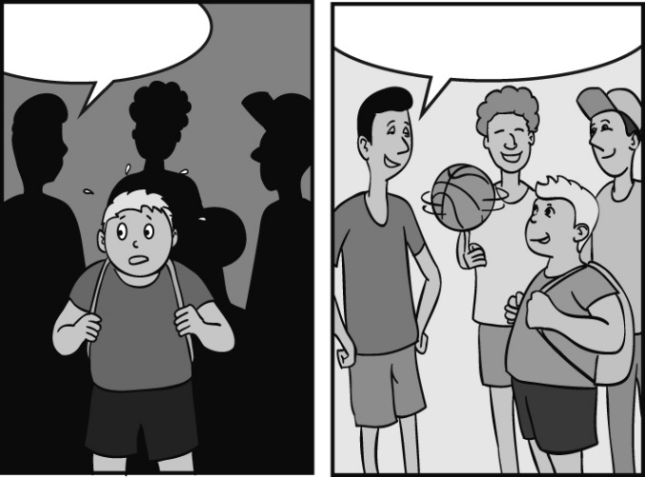
1._________________________
___________________________
___________________________
2._________________________
___________________________
2
1
- Imagine you are Robert’s friend and he sent you this email. Write an email to Robert and answer the questions. Write 25-35 words.

FROM: robertman@ymail.com
Hi!
Let’s go to the cinema tomorrow. I need to relax and spend some time with real friends. What time can you get there? Where shall we meet? What would you like to do after the cinema?
________________________________________________________________________________________________________________________________________________________
________________________________________________________________________________________________________________________________________________________
________________________________________________________________________________________________________________________________________________________

