5
Test A
Unit Shopping around town
School: _______________________________________________________________
Name: _________________________________________ Class: ______ No.: ______
Date: ______/______/______ Mark: ______
Enc. Educação: ______________________ Teacher: __________________________

Vocabulary

- Read these sentences. Put a tick () if the information is right and a cross (x) if it is wrong.

- People go to the cinema to watch a film.
- A chemist’s is a place where you buy clothes.
- Your parents can do all their food shopping in a supermarket.
- You can buy trainers at a shoe shop.
- You go to an accessory shop to buy a magazine.
- In a library you usually buy books.

B. Complete the five conversations.

1. What time does the film start? | a. Certainly.  b. Pardon?  c. Yes, at ten.
2. Would you like some juice? | a. Yes, I do.  b. Yes, you do like it.  c. Yes, I would.
3. I’d like some salad, please! | a. Anything else?  b. I hope so.  c. It was delicious.
4. Can you show me a green T-shirt? | a. Yes, that’s mine.  b. So do I.  c. Here you are.
5. Let’s go shopping! | a. Yes, there is.  b. I’d rather not.  c. Thanks a lot.

C. Circle the appropriate option in this dialogue.
A: Hi! I’d (1) buy / like a black T-shirt, please. Do you have this (2) in / on size 34?
B: Yes, here you are. Why don’t you (3) try / dress it on? There’s a changing (4) place / room over
there.
A: It’s (5) also / too big.
B: Oh, you should try a (6) smaller / bigger size, then.
A: How (7) many / much is it? There isn’t (8) any / some label on it.
B: It’s 15£.
A: OK. I’ll take it. Oh, I think I only have a 50£ bill.
B: No problem. Here’s your (9) order / change.

Reading Comprehension

Read this email about a famous restaurant in London.
To: tedman12@ymail.com
Subject: Last weekend

Hi Ted,
What’s up?
You’ll never guess what happened to me this weekend…?!!
On Saturday, my parents decided to try out a fancy restaurant in London, just behind my new house. And can you imagine where we went to?… To Fifteen, Jamie Oliver’s restaurant!!! I was thrilled. While I was eating, I couldn’t stop looking at the décor! Everything was just perfect!
And… the food was simply delicious…
Suddenly… can you imagine who I saw?! That’s it… Jamie Oliver himself… and he came to us and asked if the food was okay. Are you kidding me?! It was fantastic! Of course I asked him for an autograph! ;)
Ted, if you are looking for an excellent service and fine dining in a relaxed atmosphere, you have to try this restaurant. You will feel on the top of the world. The restaurant offers a large variety of Mediterranean food at reasonable prices. The service is great and the menu includes different delicious dishes.
See the attachment I’m sending you. See you on Monday!
Big hug,
Jack
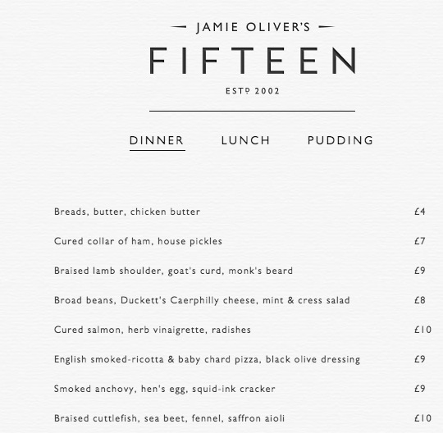

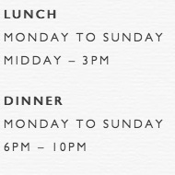
Jamie Oliver’s Fifteen is a restaurant and bar near Old Street in Islington, London. We cook elegant, rustic, honest food that flicks your senses from classic, nostalgic flavours to new, inspired dishes cooked by super-skilled young minds.

Spring salad, fennel & elderflower dressing ……. £4
Breads, butter, chicken butter ............................... £4
Cured salmon, herb vinaigrette, radishes …......... £10
Spaghetti, Wye Valley asparagus, Parmesan …… £17
Adapted from: http://www.fifteen.net/menu

A. Choose the right option.
- Who wrote the email? a) Ted b) Jack c) Jamie
- What’s the email about?
- A new restaurant
- Seeing a famous person
- A fancy weekend

B. Say whether these statements are right (R) or wrong (W).
- The restaurant in near Jack’s house.
- It’s very expensive to eat in the restaurant.
- If you eat a Spring Salad and Cured Salmon you pay more than £14.
- The restaurant is open every day.

C. Answer these questions about the text.
- What’s the name of the restaurant? ________________________________________
- What Jack’s opinion about the restaurant’s decoration?_________________________
- What did he do when he saw Jamie Oliver? __________________________________
_____________________________________________________________________
- At what time can you start having dinner in the restaurant? ______________________

D. Choose the appropriate meanings for the underlined words from the text.
1. thrilled a) extremely surprised b) very excited c) relaxed
2. kidding a) listening b) speaking to c) joking
3. rustic a) simple b) awkward c) childish
4. flicks a) disturb b) skips c) touches
Grammar

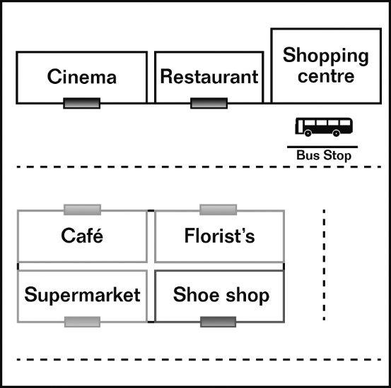
- Look at the picture and complete the sentences using the correct prepositions of place: next to, opposite, between, behind or in front of.

- The florist’s is ________ the restaurant.
- The shoe shop is ________ the florist’s.
- The café is ________ the florist’s.
- The bus stop is _______ the shopping centre.
- The restaurant is ______ the cinema and the shopping centre.

- Complete these sentences with the Past Simple or the Past Continuous.

- Jack _________ (have) dinner in Jamie Oliver’s restaurant when Kate _______ (phone) him and _______ (ask):
- – What _______ you _______(do) yesterday at nine? I _______ (try) to call you but you _________ (not answer)!
– I _________ (eating) a delicious meal with my family in Fifteen.
- When Jack _______ (meet) Jamie Oliver, he ________ (ask) people their opinion about the restaurant.
- Jamie Oliver ________ (open) his restaurant in 2002.

- Choose the appropriate option of the indefinite pronoun.

- Somebody / Everybody / Anybody loves Jamie Oliver’s restaurant. It’s amazing.
- Look there’s no one / anyone / someone inside. The restaurant is closed!
- I’m so hungry. I need to eat nothing / something / anything.
- I can’t find the menu somewhere / nowhere / anywhere. Have you seen it?
- I know anything / nothing / something about cooking. I really must learn how to cook!
Writing

- Imagine you are in Jamie Oliver’s restaurant Fifteen. Complete the dialogue.
Waiter: Good evening! Welcome to Fifteen. (1)_______________________________?
You: Yes, please. (2)_____________ spaghetti, asparagus and Parmesan, please.
Waiter: Alright. (3) _____________________________________________________?
You: An orange juice, please.
Waiter: Later (4) _______________________________________________________?
You: Yes, I’d like an apple & custard tart, please.
Waiter: OK. I’ll be back with your order. (…)
You: Excuse. I’d like to pay. (5) _________________________________________?
Waiter: That’s £29, please!

- What did you do last weekend? Write an email to a friend telling him/her: where you went, who you went with and what happened.
______________________________________________________________________________________________________________________________________________________
______________________________________________________________________________________________________________________________________________________
______________________________________________________________________________________________________________________________________________________

