6
Unit Around town world
Test A
School: _______________________________________________________________
Name: _________________________________________ Class: ______ No.: ______
Date: ______/______/______ Mark: ______
Enc. Educação: ______________________ Teacher: __________________________

Vocabulary

- Read these sentences. What is the word for each sentence?

- People can cross a river if they walk over this. B __ __ __ __ __
- People come to learn about history and very old things in here. M __ __ __ __ __
- This is the most common public transport used by people. B __ __
- You can catch a train from this place. S __ __ __ __ __ __
- You do the check-in and wait for the plane here. A __ __ __ __ __ __
- It’s where we learn to read, write among other things. S __ __ __ __ __

- Which notice (A-H) says this (1-6)?
AA
Scary Amusement Park
This weekend only
Free entrance
10 am – 2 pm

- Make sure you arrive at school on time for this.
- You should not ride your bike in this area.
- If you are younger than 15, you do not need to pay to go in here.
BA
Madison theatre
925 384
At school? Discounts for coming to 3 pm show.
- If you go this Saturday morning you don’t have to pay.
- Students pay less for tickets if they go to this in the afternoon.
CA
theatre club
Can you act?
Come and audition!
986 443

- You need to call this number if you are interested in a play.
EA
Art Gallery
Free entrance
for under 15s every day
Long Bridge – Water Sports
Beginners’ lessons
Saturday: 9-11 am
DA
FA
History Museum
Activities for 12-15 year olds
Entrance – 2$
For information: 832 132

HA
GA
Public Green Park
No skateboarding or cycling please
Year 7
Trip to the museum - Friday
Bus leaves at 3 pm
Don’t be late!

C. Complete the dialogue with ONE word in each space.

A: Excuse (1) _______, can you (2) _______ me where the train station (3) _______?
B: Yes, it’s on High Street.
A: How do I (4) _______ there?
B: Well, (5) _______ straight (6) _______ and then take the second turning (7) _______ your left. The station is next (8) _______ the post office.
Reading Comprehension
Read the magazine article about Richard Watson’s school trip to London.

My school trip to London by Richard Watson

Liverpool is my hometown and I never had the chance to visit other cities, but last month I was able to do it! It was my first school trip and my first time in London! I had a great time in London. I went with three teachers and all my classmates. I missed my family at first but by the end of the holiday, I didn’t want to go home!
On my favourite day, we went on a really long walk through the city. We had to carry all our things on our backs which was hard work but we never got bored because we all chatted the whole time. First we crossed the Westminster Bridge, which is over the river Thames. Then we saw Big Ben, St Margaret’s Church and the House of Lords. Afterwards, we went to the Parliament Square. We visited the Buckingham Palace just before our picnic lunch in St James Park. And later in the afternoon we took the bus back to Lee Valley Campsite, where we were camping. We camped there for a week.
Near the lake four of my friends tried to fish, without success! I helped build the fire instead. The teachers and one of the older students made supper, then we sat around the fire and sang songs.
On that first night we decided not to sleep inside the tents, but outdoors because we wanted to look at the stars. Some of my classmates made “animal” noises trying to make us afraid, but we were still laughing at midnight because we were having so much fun. I’ll never forget that school trip.
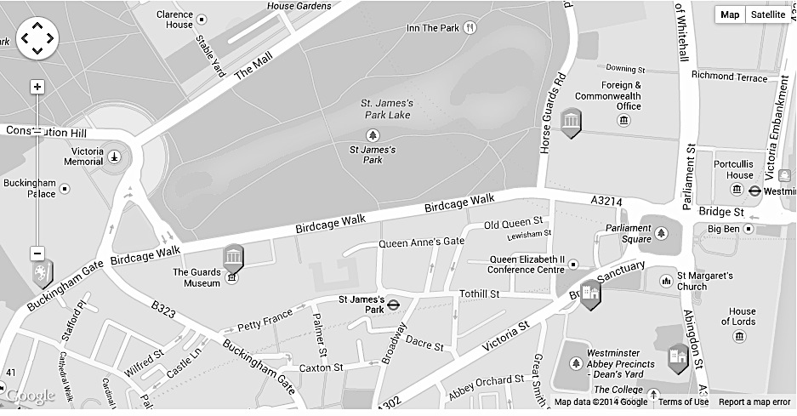
Adapted from: Key for School Trainer
(London map from: http://www.londonpass.com/)
- Say whether these statements are right (R), wrong (W) or doesn’t say (DS).
- Richard was happy on the first day because he was with his family.
- The weather was fine on Richard’s favourite day.
- James talked a lot with his classmates on the walk.
- After the picnic lunch, they visited the Buckingham Palace.
- Some of Richard’s friends caught four fish in the lake.

- Answer these questions about the text.
- Where does Richard live? _________________________________________________
- Who went with Richard to London? __________________________________________
- Where did they stay during this school trip? ___________________________________
- How long did they stay in London? __________________________________________
- Why did they sleep outside? _______________________________________________


- Find words in the text that mean the following:

1. opportunity (paragraph 1)
2. colleagues (paragraph 1)
3. take (paragraph 2)
4. difficult (paragraph 2)
5. attempted (paragraph 3)

Grammar

- Add a suffix to the words below to create a new word. Be careful because some are not necessary!
er ment ship or hood ful ist ness

      - child_____ 2. dark_____ 3. friend_____ 4. power_____ 5. develop_____

- Write the opposites of the following word by adding a prefix.

- perfect ______________
- legal ______________
- fair ______________
- behave ______________
- agree ______________

- Complete the sentences with the appropriate preposition of movement: across, towards or through.

- We have to walk ___________ that tunnel first.
- Look, Richard is walking ________ the bus. Let’s call him.
- Look at that squirrel running _______ the park! So cute!
- Oh, no! That strange dog is walking _______ me! I’m scared!
- While Richard was walking _________ the Westminster Bridge, he twisted his ankle.

- Choose the best option for the future form: will, be + going to or Present Continuous.

- We will have / are having lunch tomorrow at half past one.
- I think I’ll visit / ‘m going to visit the London Dungeons tomorrow.
- I’ll travel / ‘m going to travel to Paris next year.
- I promise I ‘ll come / ‘m going to come back one day.
- Look at the sky. It will rain / is going to rain.
Writing
- Richard wants to travel to Paris. Read the text and complete this enrolment form for him.
French Language Programme
Hi, my name is Richard Mathew Watson. I live in Liverpool, in England, but I was born on 4th April 2002 in Dublin, Ireland. I moved to England when I was five.
Now that I’m older I want to travel and see the world… so I’d like to start with Paris! I’d love to visit the Eiffel tower. At school I only learnt the basics of French for a year. So going there is also an opportunity to learn more!

Student Information Form
General Information
Last name | 1.
First name | 2.
City/Town | 3.
Country | 4.
Personal Information
Date of birth | 5.
Nationality | 6.
Numbers of years of previous French study | 7.
Reasons for travelling | 8.

- What was your favourite (school) trip? Use the following questions to help you create your text.
Where and when did you go? Who did you go with? What did you see? What did you do? Why did you enjoy it? Would you like to come back?
________________________________________________________________________________________________________________________________________________________
________________________________________________________________________________________________________________________________________________________

