Unit 1 About myself & Unit 2 School and friends

Name: ______________________________________________________ Class: ____ No.: _______
Date: _______________________________________________________ Score: _______________
Enc. Educação: ________________________________Teacher: ________________________

Listening 15 minutes
- You will hear Mia Fizz talking about herself. Listen to the audio twice and complete the table.

Name: | Mia
Surname: | Fizz
Age: | - ________________
Date of birth: | - ________________
Nationality: | - ________________
Favourite pet: | - ________________
Favourite hobby: | - ________________

- Listen to the audio again and circle the correct option.

- Mia Fizz is a famous young YouTuber / blogger.

- Georgie is Mia’s mother / step-father.
- Sienna and Karma are Mia’s parents / half-sisters.
- Mia has got / hasn’t got a dog.
- Mia is doing five videos for her YouTube channel every week / every day.

Unit 1 About myself & Unit 2 School and friends

Name: ______________________________________________________ Class: ____ No.: _______
Date: _______________________________________________________ Score: _______________
Enc. Educação: ________________________________Teacher: ________________________

Reading Comprehension 20 minutes

“Star” athletes at school

5  10  15  20  25 |   Most students spend too much time on computers, video games and television which makes them inactive in their lifestyles. Research proves that half of the students who are inactive at school are overweight and are usually less physically fit. Participating in sports and other physical activities helps children develop a sense of friendliness, team spirit, confidence among them and it has good effects on their studies as well.  Some of the most famous stars in Hollywood were athletes at their schools and universities. The list of superstars who had an athletic career in the past is huge. They played popular sports such as football, basketball, hockey, and tennis at school.  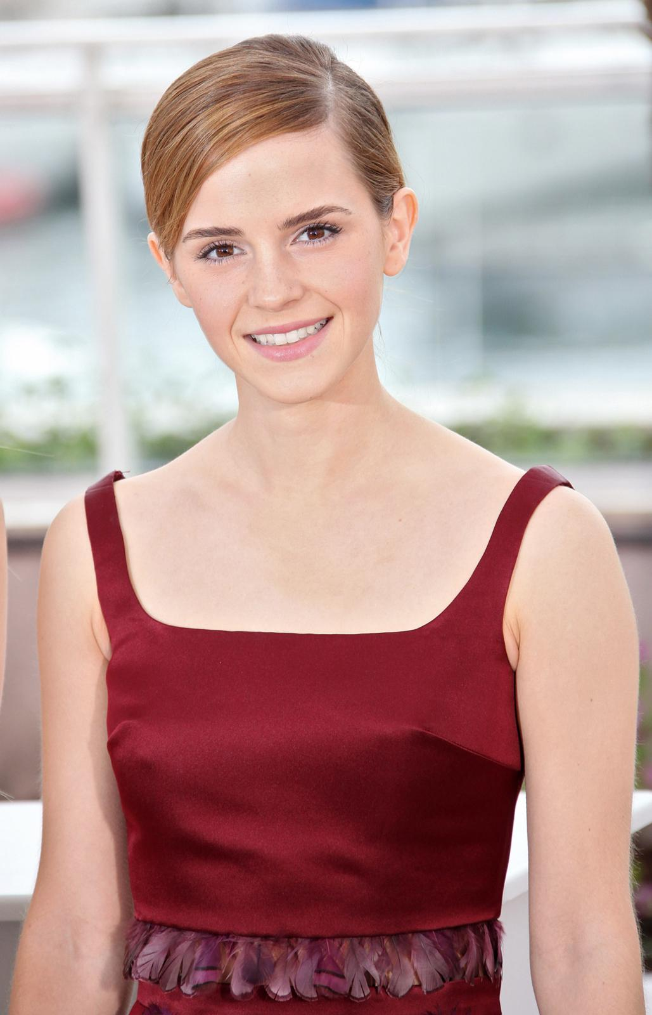  Emma Watson is best known for playing the character of Hermione Granger, one of Harry Potter’s best friends in the ‘Harry Potter’ films, but she was also an athlete when she was younger.  Emma Watson was born on 15th April 1990, in Paris. Her parents, both British lawyers, are Jacqueline Luesby and Chris Watson. Her brother, Alex, was born three years later. Her parents divorced when Watson was 5, and she moved to Oxfordshire, in England. Watson studied singing, acting and dancing, and performed in school plays, but field hockey was also a big part of her life growing up. It was her favourite sport.  She played field hockey since she was four, so at school and the university, she joined the hockey team. Besides that, she has always been involved in various competitions in athletics and rowing. According to her teachers, she was very active and cheerful.  Famous people are no different. Whether they are musicians, politicians, actors or athletes, they all have more than one skill they are good at. So, whatever you do, don’t just sit at home. Get out there and play!


- Find the opposites of these words in the text.

- active (paragraph 1) _______________________
- slim (paragraph 1) _______________________
- small (paragraph 2) _______________________
- older (paragraph 3) _______________________
- sad (paragraph 5) _______________________

- Match the words from the text with the definitions.
- famous people
- an ability to do an activity or job well
- to be right size or shape
- the quality of being certain of your abilities
- someone whose job is to give advice to people about law and speak for them in court
- fit (line 4)
- confidence (line 6)
- stars (line 8)
- lawyer (line 16)
- skill (line 27)

- Decide if these statements are right (R) or wrong (W) according to the text.

- Students who don’t exercise will probably have weight problems.
- There are many celebrities who weren’t good at sports.
- Emma Watson is known for being a good athlete at school.
- Emma Watson and her brother, Alex, are twins.

- Answer the questions about the text.

- Why are sports and physical activities important?
____________________________________________________________
- When was Emma Watson born?
____________________________________________________________
- When did she start playing field hockey?
____________________________________________________________
- What was Emma’s favourite sport?
____________________________________________________________

Grammar 10 minutes
- Read the sentences and choose the correct option.
1. My parents sent _________________ a postcard from England.
a) I b) me c) my
2. _________________ school is in Bristol. Where is _________________?
a) Me… your b) My… yours c) My… your
3. I hate drawing. Can _________________ help _________________?
a) your… me b) you… my c) you… me
4. Emma likes sports. _________________ hobbies are running and swimming.
a) Her b) Hers c) She
5. I am teaching _________________ to play the piano.
a) me b) myself c) my

- Complete these sentences with the Present Simple or the Present Continuous.

- Mark’s football match _______________________ (start) at eight o’clock every day, but he always _______________________ (arrive) fifteen minutes earlier.
- At the moment Sarah _______________________ (not study). She _________________ (watch) a film with her friend Rita.
- Larry and Sam often _______________________ (play) computer games together, when they _______________________ (not have) homework to do.
- – What _______________________ (you / do) now?
– I _______________________ (listen) to music in my bedroom.
- Meg _______________________ (not / go) to the swimming pool by bus, she _______________________ (prefer) walking.

- Complete the sentences with the Past Simple of regular verbs.

- Yesterday the football game _________________ (start) at 9:30 pm and we _________________ (arrive) home at 10 pm.
- Last summer we _________________ (play) hockey every day. We _________________ (try) to practise for the big game.
- _________________ you _________________ (invite) all your friends to the party?
- Last weekend my family and I _________________ (stay) in London and we _________________ (visit) the Big Ben.
- I never _________________ (stop) playing the piano. I _________________ (study) it for many years and I still play, because I enjoy it so much.

- Complete the sentences with the Past Simple of the irregular verbs in brackets.

Last month I (1)______________ (have) a very important surf competition. I (2)_____________ (go) to Widemouth bay in England with all my family. All my friends (3)__________(be) there too. I (4)__________ (do) an amazing championship and I (5)_________ (win) the competition.

Writing 30 minutes
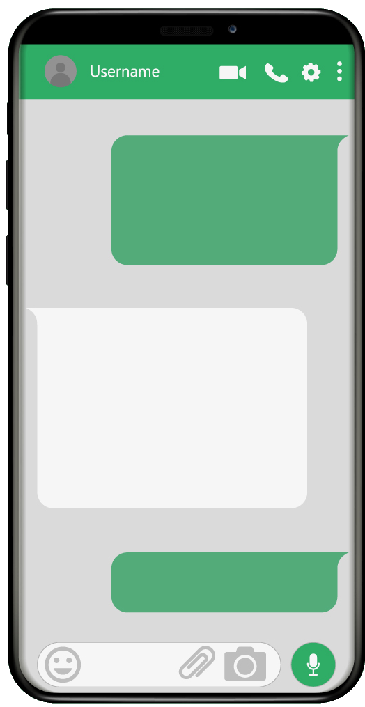
- You received this message from your English friend. Imagine you want to participate in this championship. Complete the enrolment form to validate your application.
There’s a new sport at our school: field hockey. Let’s join in? Visit our school website and enrol. I did it! ;)
Hi! You called me. What’s up?
ENROLMENT FORM
First name: | 1.
Surname: | 2.
Age: | 3.
Gender: | 4. male ☐ female ☐
Address: | 5.
Email: | 6.
Hometown: | 7.
Country: | 8.
...
- Choose one of the topics and write 50-80 words.

OPTION 1

J. K. Rowling is the author of the “Harry Potter” books. Write a short text about her. Use the information below to help you.

NAME | Joanne
SURNAME | Rowling
PLACE OF BIRTH: | Gloucestershire, England
DATE OF BIRTH: | 31st July 1965
JOB | - best known for writing the Harry Potter fantasy series  - novelist, philanthropist, film producer, television producer
PAST | - Researcher and bilingual secretary for Amnesty International  - First book: Harry Potter and the Philosopher’s Stone (1997)
Major achievements | - 2010 – “Most Influential Woman in Britain” by leading magazine editors  - Supports charity: Comic Relief, One Parent Families, etc.

_________________________________________________________________________________________________________________________________________________________________________________________________________________________________________________________________________________________________________________________________________________________________________________________________________________________________________
_____________________________________________________________________________________

OPTION 2
Imagine you were in London and you had the chance to interview J. K. Rowling. Complete the interview using the information given in the table above.
YOU | Good morning. Thanks for this interview.
ROWLING | 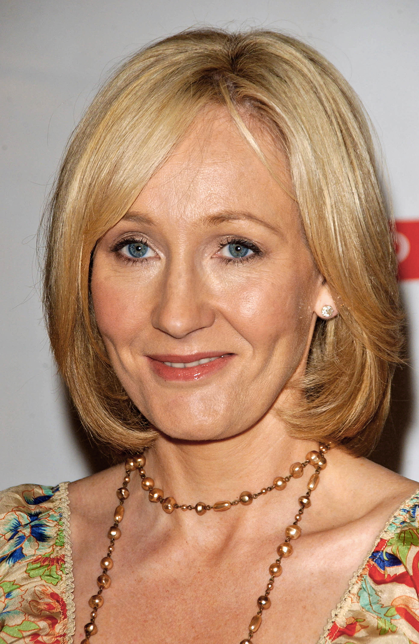  (1) _____________________________________________.
YOU | (2) _____________________________________________.
ROWLING | It’s Joanne Rowling.
YOU | (3) ______________________________________________?
ROWLING | I was born on 31st July 1965.
YOU | Well, you were born in England. Where exactly?
ROWLING | (4) _____________________________________________?
YOU | (5) _____________________________________________?
ROWLING | I am a philanthropist, film producer and television producer.
YOU | And before being a writer/novelist, what did you do?
ROWLING | (6) _______________________________________________.
YOU | Your first book was Harry Potter and the Philosopher’s Stone.  (7) ___________________________________________?
ROWLING | I wrote it in 1996/1997.
YOU | Well, thanks for this interview. It was really nice to meet you.
ROWLING | (8) _____________________________________________.

Speaking – Student’s pictures

Part 2


