FAST GRAMMAR WORKSHEET | 1 | UNIT 1 | GRID A


Name ___________________________________________________ No. _______ Class _______

QUESTION WORDS

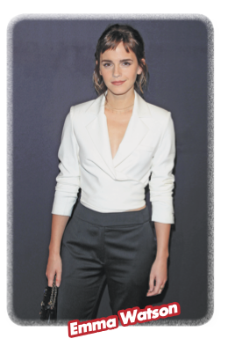
Tick the correct option.
1. …… is Emma’s surname?
(A) Who

(B) What

(C) How

(D) Why

2. …… is the lovely actress?
(A) How old

(B) How many

(C) How much

(D) How long

3. …… is she doing in Los Angeles?
(A) When

(B) Where

(C) Why

(D) What

4. …… colour does she prefer, black or white?
(A) How many

(B) Why

(C) Which

(D) Whose

5. …… cats has she got?
(A) How much

(B) How many

(C) Where

(D) How old

